

**HO CHI MINH UNIVERSITY OF TECHNOLOGY AND EDUCATION**

**FACULTY FOR HIGH QUALITY TRAINING**

**🕯✡🕮🕮✡🕯**



**IT PROJECT**

***TOPIC:* BUILDING A FASHION CLOTHING BUSINESS WEBSITE**

***Instructor****: M.S Le Thi Minh Chau*

***Made by student****:*

1. *Tran Duc Quang 21110793*
2. *Tran Binh Phuoc 21110803*

Ho Chi Minh, Dec 2023

# OPENING MARKS

First of all, we would like to sincerely thank our teacher, M.S Le Thi Minh Chau, for his dedicated guidance that has helped us complete the final report of this semester's course on IT Project. Thanks to the knowledge imparted by our teacher, we have gained a solid understanding of the fundamental concepts and foundations for building a database management system. Through this project, our group would like to present the development process of a database management system, as well as programming a related project.

During the course of this project, we may have made mistakes, and therefore, we greatly appreciate any feedback from our teacher to help us improve, develop, and make our work more comprehensive. We wish our teacher good health, happiness, and success in his teaching career.

TABLE OF CONTENTS

OPENING MARKS 2

LIST OF FIGURES 6

LIST OF TABLES 9

INTRODUCTION 1

1. REASON FOR CHOOSING TOPIC 1

2. PURPOSE OF PROJECT 2

3. IMPLEMENTATION METHOD 2

CONTENT 3

CHAPTER 1. DEVELOPMENT ENVIRONMENTAL 3

1.1. IDE: IntelliJ IDEA 2021.1 3

1.2. Server: Apache-tomcat-9.0.80 3

1.3. Java version: jdk-20.0.2 3

CHAPTER 2. DESCRIPTION OF SYSTEM REQUIREMENTS 4

2.1. Funtional survey 4

2.2. List of business function requirements 9

2.3. List of functional requirements 9

2.4. List of non-functional requirements 10

CHAPTER 3. REQUIREMENT MODELING 11

3.1. Usecase diagram 11

3.1.1. Login 12

3.1.2. Register 13

3.1.3. Log out 13

3.1.4. View personal information 14

3.1.5. Edit personal information 15

3.1.6. Change password 15

3.1.7. Order product 16

3.1.8. View product information 17

3.1.9. Search product 18

3.1.10. View order history 19

3.1.11. Order confirmation 19

3.1.12. Cancel order 20

3.1.13. Add new products 21

3.1.14. Product updates 22

3.1.15. Disable product 23

3.1.16. View order history 25

3.2. Sequencediagram 25

3.2.1. Login 26

3.2.2. Register 26

3.2.3. Search 27

3.2.4. Update user information 27

3.2.5. Add to cart 28

3.2.6. Order management 28

3.2.7. Product management 29

3.3. Entity Relationship Diagram (ERD) 29

3.4. Class Diagram 30

CHAPTER 4. SYSTEM DESIGN AND IMPLEMENTATION 34

4.1. Admin page 34

4.1.1. Views 34

4.1.2. Controller 37

4.1.2.1. Login Controller 38

4.1.2.2. Order Controller 38

4.1.2.3. Product Controller 39

4.1.2.4. Customer Controller 40

4.1.3. Service 41

4.2. Customer page 42

4.2.1. Views 42

4.2.2. Controller 47

4.2.2.1. Account Controller 48

4.2.2.2. Cart Controller 48

4.2.2.3. Email Controller 49

4.2.2.4. Login Controller 50

4.2.2.5. Order Controller 52

4.2.2.6. Product Controller 52

4.2.2.7. Review Controller 53

4.2.3. Service 54

CHAPTER 5. CONCLUSION 55

5.1. Task manager 55

5.2. Project achivement 56

5.3. Advantages and disadvantages 56

5.4. Future developments 57

REFERENCES 58

# LIST OF FIGURES

Figure 1.1. Jdk, Tomcat and Java 3

Figure 2.1. Home page survey 4

Figure 2.2. Product page survey 4

Figure 2.3. Product details page survey 5

Figure 2.4. Login page survey 5

Figure 2.5. Cart page survey 6

Figure 2.6. Order details page survey 6

Figure 2.7. My account page survey 7

Figure 3.1. Usecase diagram 11

Figure 3.2. Login sequence diagram 26

Figure 3.3. Register sequence diagram 26

Figure 3.4. Search sequence diagram 27

Figure 3.5. Update user information sequence diagram 27

Figure 3.6. Add to cart sequence diagram 28

Figure 3.7. Order management sequence diagram 28

Figure 3.8. Product management sequence diagram 29

Figure 3.9. Entity relationship diagram 29

Figure 3.10. Cass diagram 30

Figure 3.11. Customer model 30

Figure 3.12. Order model 31

Figure 3.13. Product model 31

Figure 3.14. Order details model 32

Figure 3.15. Cart model 32

Figure 3.16. Cart item model 32

Figure 3.17. Category model 33

Figure 3.18. Color model 33

Figure 3.19. Size model 33

Figure 3.20. Image model 33

Figure 3.21. Review model 33

Figure 4.1. Overall admin views 34

Figure 4.2. Admin login page 34

Figure 4.3. Admin order management page 35

Figure 4.4. Admin order detail 35

Figure 4.5. Admin product management page 35

Figure 4.6. Admin add product 36

Figure 4.7. Admin edit product 36

Figure 4.8. Admin customer management view 36

Figure 4.9. Admin add customer 37

Figure 4.10. Admin edit customer information 37

Figure 4.11. Overal adminl controller 37

Figure 4.12. Login controller function 38

Figure 4.13. Order controller function 38

Figure 4.14. Product controller function 39

Figure 4.15. Customer controller function 40

Figure 4.16. Customer home page 42

Figure 4.17. Customer login page 42

Figure 4.18. Customer register page 43

Figure 4.19. Customer forgot password page 43

Figure 4.20. Customer insert OTP page 43

Figure 4.21. Customer product page 44

Figure 4.22. Customer product details page 44

Figure 4.23. Size table page 44

Figure 4.24. Customer cart page 45

Figure 4.25. Customer mini cart 45

Figure 4.26. Order confirmation page 45

Figure 4.27. Customer account page 46

Figure 4.28. Customer edit information page 46

Figure 4.29. Email sending 46

Figure 4.30. Register account email 47

Figure 4.31. Forgot password email 47

Figure 4.32. Customer overall controller 47

Figure 4.33. Customer account controller function 48

Figure 4.34. Customer cart controller function 49

Figure 4.35. Customer forgot password function 50

Figure 4.36. Customer logn controller function 51

Figure 4.37. Customer product controller function 52

Figure 4.38. Review controller function 53

Figure 4.39. Customer service implementation 54

# LIST OF TABLES

Table 2.1. Page survey advantages and disadvantages 7

Table 3.1. Overall description of the actors 11

Table 3.2. Details description of login function 12

Table 3.3. Details description of register function 13

Table 3.4. Details description of logout function 13

Table 3.5. Details description of view personal information function 14

Table 3.6. Details description of edit personal information function 15

Table 3.7. Details description of chage password function 16

Table 3.8. Details description of make order function 16

Table 3.9. Details description of view products function 17

Table 3.10. Details description of search product function 18

Table 3.11. Details description of view order history function 19

Table 3.12. Details description of order confirmation function 19

Table 3.13. Details description of cancel order function 20

Table 3.14. Details description of add new function 21

Table 3.15. Details description of update product function 22

Table 3.16. Details description of disable product function 23

Table 3.17. Details description of view order history function 25

Table 4.1. Order controller description 39

Table 4.2. Product controller function description 39

Table 4.3. Customer controller functio description 41

Table 4.4. Customer account controller description 48

Table 4.5. Customer cart controller function description 49

Table 4.6. Customer forgot password function description 50

Table 4.7. Customer logn controller function description 51

Table 4.8.. Customer product controller function description 53

Table 4.9. Review controller function description 54

# INTRODUCTION

## REASON FOR CHOOSING TOPIC

In today's rapidly evolving Information Technology landscape, the internet has cemented its position as an integral part of our daily lives. Alongside this, the retail fashion industry has seen tremendous growth, and the incorporation of information technology into the management of online clothing stores has become an inevitable trend.

Imagine a modern web-based clothing store management system, where shop owners can efficiently oversee and manage their online store without needing to be physically present. With just a computer and an internet connection, this software provides convenience and flexibility in the management of the fashion boutique. Functions such as inventory management, sales analytics, staff supervision, and customer interaction are made simpler and more efficient than ever before.

However, to maximize the benefits of this clothing store management software, it is crucial to intelligently and efficiently build and maintain the underlying database. The database serves as the core of the system, housing critical information about products, customers, employees, and transactions. It is through this database that boutique owners can meticulously track and analyze data, enabling them to make informed and dependable business decisions.

With the potent capabilities of this web-based clothing store management software and its database, not only can the boutique owner exercise greater control and flexibility, but the Customers can also experience comfortable online shopping and selection that information technology brings. Nevertheless, it's essential to acknowledge that during the deployment and utilization of the software, challenges and errors may arise, especially in the coding and maintenance of the database. Therefore, to enhance our proficiency in constructing and effectively utilizing databases, we have chosen the topic of online clothing store management as the focus of this project.

We extend our heartfelt gratitude to M.S Le Thi Minh Chau for her invaluable assistance in completing this project. While significant efforts have been invested, we understand that errors may surface in the process of compiling this thesis. We eagerly anticipate your feedback, which will undoubtedly aid in our continuous improvement for future endeavors.

We sincerely appreciate your support and guidance!

## PURPOSE OF PROJECT

* Build websites for database administrators.
* Build a website for users to buy clothes online.
* Successfully apply learned web building technologies to the project.
* Learn and successfully apply Hibernate/JPA, Java Servlet, BootStrap and MySQL Workbench to the topic.

## IMPLEMENTATION METHOD

* Research similar applications on the internet: Hades, So Vintage, Yame...
* Learn and apply Servlet and Hibernate to build API for the system.
* Use MySQL to store the database.
* Proficient in applying HTML, CSS, JavaScript and BootStraps to build user interfaces and handle user logic using Java Servlet, Hibernate JPA.

# CONTENT

# DEVELOPMENT ENVIRONMENTAL

## IDE: IntelliJ IDEA 2021.1

IntelliJ IDEA 2021.1 is a robust and user-friendly integrated development environment (IDE) that caters to a wide range of programming languages. It provides efficient and intelligent features such as code completion, refactoring, debugging, testing, and deployment tools. IntelliJ IDEA 2021.1 supports various languages, including Java SE, Java EE, and many others. This IDE is equipped with advanced capabilities to facilitate fast and smart code editing, making it a popular choice among developers.

## Server: Apache-tomcat-9.0.80

Apache Tomcat 9.0.80 is an open-source web server and servlet container that implements the Jakarta Servlet, Jakarta Server Pages, Jakarta Expression Language, and Jakarta WebSocket specifications. It offers high performance, scalability, and integration with native server technologies. It also supports HTTP/2, TLS virtual hosting, and multiple certificate support. Apache Tomcat 9.0.80 is compatible with Java SE 8 and later versions.

## Java version: jdk-20.0.2

JDK 20.0.2 is the latest update release of the Java SE platform. It contains security fixes, bug fixes, and performance improvements. It also includes IANA time zone data 2023c, which reflects the latest changes in daylight saving time and regional settings around the world. JDK 20.0.2 supports the development and execution of Java applications that use the new features and enhancements introduced in Java SE 20, such as sealed classes, foreign-memory access API, and vector API.



Figure 1.1. Jdk, Tomcat and Java

# DESCRIPTION OF SYSTEM REQUIREMENTS

## Funtional survey

After consulted website Hades, SoVintage we got some highlight of thems:

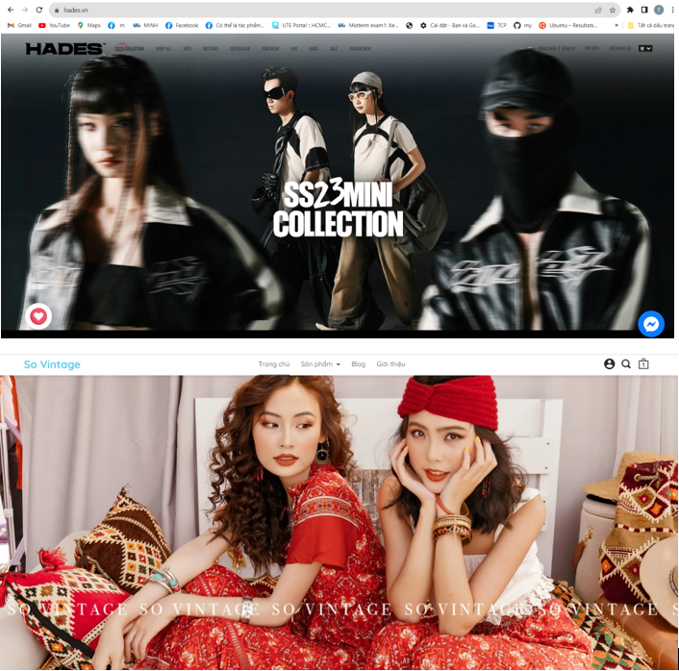

Figure 2.1. Home page survey

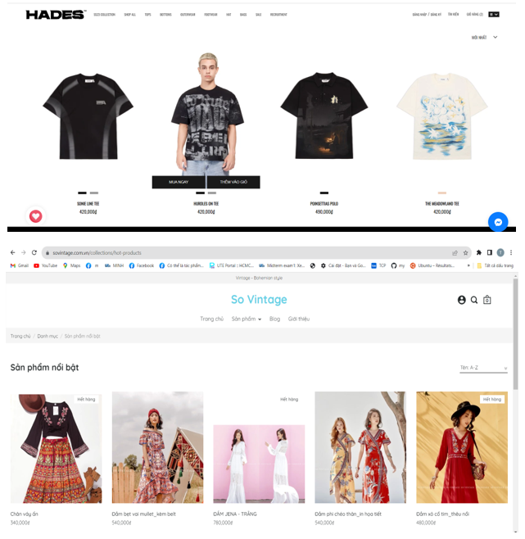

Figure 2.2. Product page survey

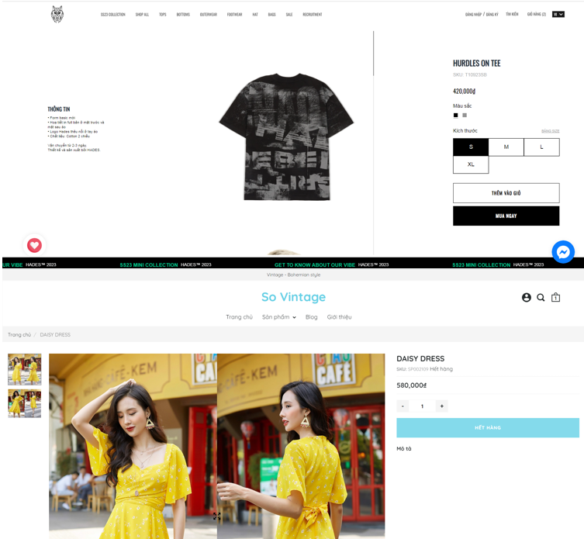

Figure 2.3. Product details page survey

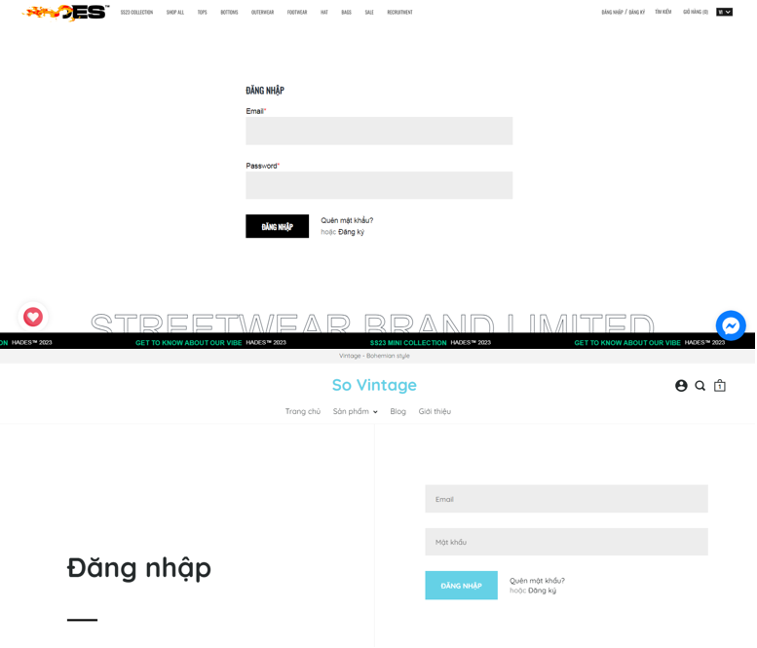

Figure 2.4. Login page survey

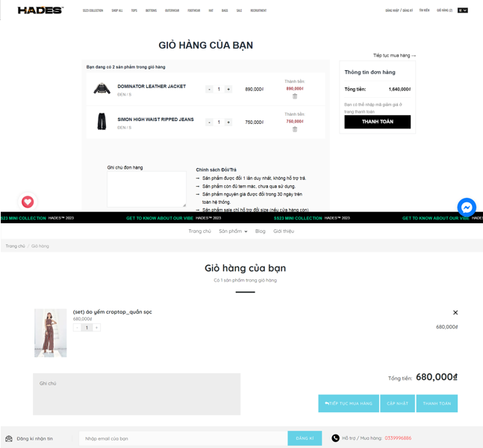

Figure 2.5. Cart page survey

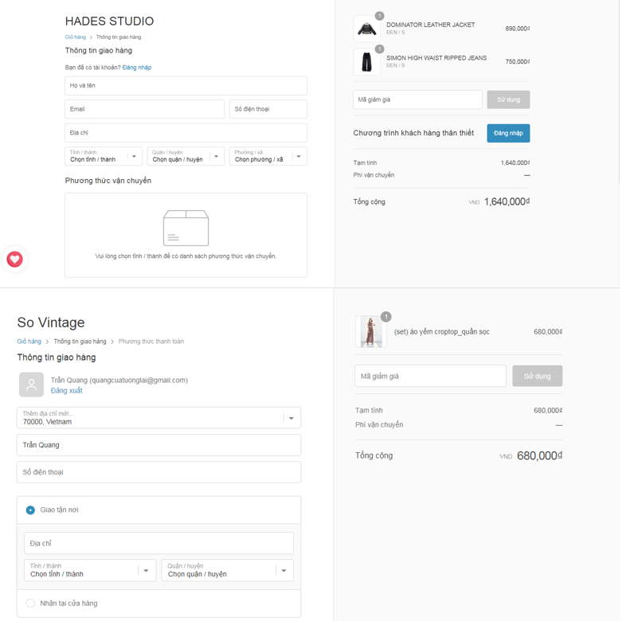

Figure 2.6. Order details page survey

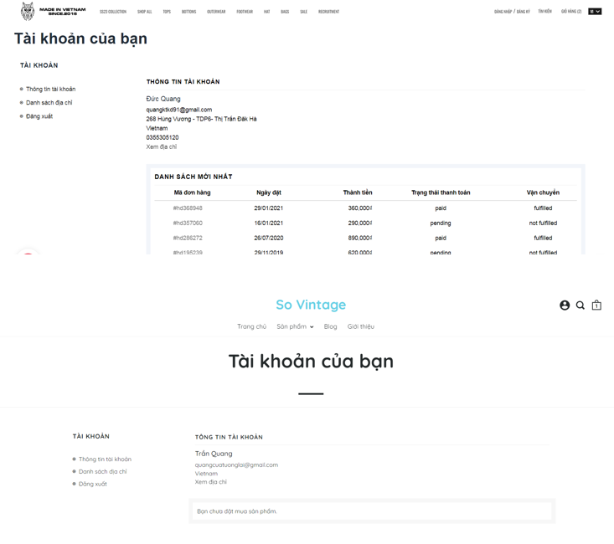

Figure 2.7. My account page survey

After consulting the major websites above, we can summarize the basic functions in each page:

Table 2.1. Page survey advantages and disadvantages

|  |  |  |
| --- | --- | --- |
| Page | Pros | Cons |
| Home Page  <https://hades.vn/>  <https://sovintage.com.vn/> | - User-Friendly Design, using interactive elements: buttons, forms, sliders, … creating enhance user engagement.  - Fast response speed. | The animation when clicking on a button are quite garish on Hades’s page, with Sovintage they’re display too much product on home page we can’t see what really stand out. |
| Product Page  <https://hades.vn/collections/all>  <https://sovintage.com.vn/collections/all> | - The product title, prominently displayed near the image, should be concise and descriptive, quickly conveying what the product is.  - Diverse products, each item displays the product's color palette. | With Sovintage the products are not really what they’re tagged to be. |
| Product Detail Page  <https://hades.vn/products/hurdles-on-tee>  <https://sovintage.com.vn/products/mandala-dress> | - Clear and Compelling Product Descriptions, High-Quality Product Images.  - There is a photo scroll that allows users to view different angles of that item. | Both of the webs are not showing their interactive features which is they don’t display the previous customer’s comment with the products. |
| Cart Page <https://hades.vn/cart>  <https://sovintage.com.vn/cart> | - Order information is concise, full of information, it serves as a quick reference point for customers.  - Has all necessary order adjustment functions for customers. |  |
| Payment Page | - Easy Checkout Process with simple checkout process simple, clear instructions and minimal steps.  - Offering multiple payment options. | - There is no user rating system for the product. |
| Account Page | - Intuitive and user-friendly, making it easy for users to understand how to log in.  - Allows users to recover their accounts if they forget their passwords, enhancing user convenience. | - Managing personal information is simple  - Address management is limited. |

We can refer to the highlights of the web beside those basic function (login, payment, search, …) such as:

- User friendly navigation: user can easily find the products or information they are looking for as the design style of these web are minimalism. But sometimes their categorize may be too details make user confused.

- Products are sorted by group or by collections help user are easily to find the style that they are into.

## List of business function requirements

* Product Management:

**-** Display products by type

**-** Search for products

**-** Filter products

**-** Images and product information

* User management:

- Log in

- Register

- Payment orders

- Cancel orders

- Account management

- Add reviews

- Purchase history

* Pay:

- COD payment

- Stripe payments

## List of functional requirements

**-** Add, disable, update products.

- Update order status.

- Add, ban, update users.

## List of non-functional requirements

**-** The system has security and decentralization functions.

- Passwords and sensitive information of users are encrypted before being written to the database.

# REQUIREMENT MODELING

## Usecase diagram

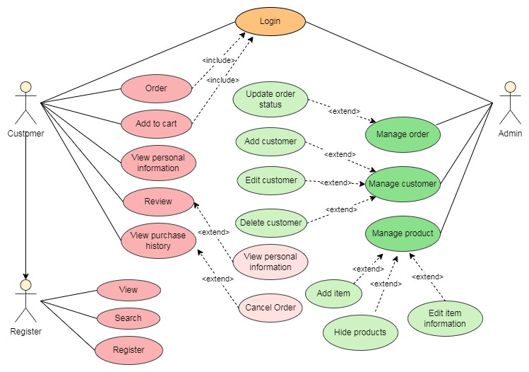

Figure 3.1. Usecase diagram

Detailed description of the actors:

Table 3.1. Overall description of the actors

|  |  |
| --- | --- |
| Agent name | Function |
| Non-Register Customer | - Regist  - View product information  - Search product |
| Customer | - Regist - Log in  - View product information  - Search product  - Order  - Add product to cart  - View personal information  - Product reviews  - View purchase history  - Password Recovery |
| Admin | - Log in  - Manage order  - Manage product  - Manage customer  - Manage product reviews |

### Login

Table 3.2. Details description of login function

|  |  |
| --- | --- |
| Name | LOG IN |
| Quick description | Log in to perform functions corresponding to your position on the Website. |
| Objects | Admin, Customers |
| Prerequisites | The user already has an account in the system. |
| When successful | The user is authenticated and the system exposes the functionality corresponding to the user's role. |
| Interactive stream |  |
| Success |  |
| Failure | If login fails: User cannot access the system, need to check login information again.  If the user enters the wrong username or password, it could be both. The following tasks are performed:  1. The system describes the reason the authentication failed.  2. The system notices the user logging in again.  3. When the user re-enters the login name and password, step 3 in Basic flow is performed. |
| Extension | If the user enters the wrong username or password, it could be both. The following tasks are performed: |

### Register

Table 3.3. Details description of register function

|  |  |
| --- | --- |
| Name | REGISTER |
| Quick description | Used to create new accounts for customers when they need to use the functions - Order products, view and edit personal information, track transaction history. |
| Objects | Guest does not have an account |
| Prerequisites | The registered account must not be the same as an existing account in the database and the registration information must be valid with the requirements. |
| When successful | Successful registration will add information to the database |
| Interactive stream |  |
| Success | 1. 1. Select the "Register" function |
| Failure | 1. 2. Enter the customer's username, password, personal information, etc |
| Extension | 3. The system checks the validity of the information just entered |

### Log out

Table 3.4. Details description of logout function

|  |  |
| --- | --- |
| Name | LOG OUT |
| Quick description | Exit functions corresponding to roles in the Web. |
| Objects | Admin, Customers |
| Prerequisites | The user is logged in to the system. |
| When successful | Returns the user to the home page, the right side returns to the word "Login" or returns to the "Login" page if they are an admin or shipper |
| Interactive stream |  |
| Success | User clicks “Log out” |
| Failure | The system exits the user account and returns to the web home page |
| Extension | If logging out fails, the following actions are performed |

### View personal information

Table 3.5. Details description of view personal information function

|  |  |
| --- | --- |
| Name | VIEW PERSONAL INFORMATION |
| Quick description | Used to check and review information related to personal issues. |
| Objects | Client |
| Prerequisites | Login to the website. |
| When successful | Information is displayed on the screen. |
| Interactive stream |  |
| Success | 1. Username and Password authentication system  2. Select the function “Personal information”  3. Display the corresponding information that the user entered when creating the account. |
| Failure | If the user cannot load the personal page. The following tasks are performed:  1. The system displays a message asking the user to wait a moment.  2. Return to step 2 in Basic flow if you want to continue viewing information. |
| Extension | Do not have |

### Edit personal information

Table 3.6. Details description of edit personal information function

|  |  |
| --- | --- |
| Name | EDIT PERSONAL INFORMATION |
| Quick description | Used to change customer's personal information |
| Objects | Client |
| Prerequisites | Log in with your customer account to the website. Edited information must be valid. |
| When successful | Information will be updated to the database if edited successfully. |
| Interactive stream |  |
| Success | 1. The system will confirm the customer's account.  2. Select "Personal information"  3. Select the “Change account information” button  4. Enter the information you want to edit, when finished, click "Change"  5. New data will be updated. |
| Failure | If the user cannot adjust the information. The following tasks are performed:  1. The system describes the reason why it cannot be edited.  2. Return to step 4 in Basic flow if you want to continue the operation. |
| Extension | Do not have |

### Change password

Table 3.7. Details description of chage password function

|  |  |
| --- | --- |
| Name | CHANGE THE PASSWORD |
| Quick description | Used to change the customer's password |
| Objects | Client |
| Prerequisites | Log in with your customer account to the website. |
| When successful | Information will be updated to the database if edited successfully. |
| Interactive stream |  |
| Success | 1. The system will confirm the customer's account.  2. Select "Personal information"  3. Select the “Change password” button  4. Enter the current password, new password and re-enter the new password a second time to confirm, when completed, click "Change"  5. New data will be updated. |
| Failure | If the user does not update the password successfully. The following tasks are performed:  1. The system describes the reason why it cannot be edited.  2. Return to step 4 in Basic flow if you want to continue the operation. |
| Extension | Do not have. |

### Order product

Table 3.8. Details description of make order function

|  |  |
| --- | --- |
| Name | ORDER PRODUCTS |
| Quick description | Make an order for clothes, choose a delivery location |
| Objects | Client |
| Prerequisites | Log in with your customer account to the website. |
| When successful | Information about order details will be saved so customers can check at any time. |
| Interactive stream |  |
| Success | 1. The system will confirm the customer's account  2. Find the components the customer wants  3. Add to cart  4. Select “Payment”  5. Fill in the necessary fields such as address, phone number, ...  6. Then select the payment method. If the customer chooses the payment method, Stripe will be redirected to Stripe's login page for the customer to pay. |
| Failure | If the user cannot order clothes. The following tasks are performed:  1. The system describes the specific reason  2. Return to step 5 in Basic flow if you want to continue the operation. |
| Extension | Do not have |

### View product information

Table 3.9. Details description of view products function

|  |  |
| --- | --- |
| Name | VIEW PRODUCT INFORMATION |
| Quick description | Used to view information related to products and clothing |
| Objects | Customers, visitors |
| Prerequisites | Visit the website. |
| When successful | Product information is displayed on the screen. |
| Interactive stream |  |
| Success | 1. Access the homepage.  2. In the products by type section, select any product to view details  3. Display corresponding product information. |
| Failure | If the user cannot access the home page. The following tasks are performed:  1. The system displays a message asking the user to wait a moment.  2. Return to step 2 in Basic flow if you want to continue viewing information. |
| Extension | Do not have. |

### Search product

Table 3.10. Details description of search product function

|  |  |
| --- | --- |
| Name | PRODUCT SEARCH |
| Quick description | Used to find products according to customers' wishes |
| Objects | Customers, visitors |
| Prerequisites | Visit the website. |
| When successful | The searched products will be displayed on the screen |
| Interactive stream |  |
| Success | 1. Access the homepage.  2. Select products by type, or enter the product name you want to search for in the search box  3. Display corresponding products |
| Failure | If the user cannot find the product. The following tasks are performed:  1. User reloads and visits the website again  2. Return to step 2 in Basic flow if you want to continue viewing information. |
| Extension | Do not have. |

### View order history

Table 3.11. Details description of view order history function

|  |  |
| --- | --- |
| Name | VIEW ORDER HISTORY |
| Quick description | Perform a review of customers' completed transactions |
| Objects | Client |
| Prerequisites | Log in with your customer account to the website. |
| When successful | Information about orders that customers have made will be displ |
| Interactive stream |  |
| Success | 1. The system will confirm the customer's account  2. User selects "Transaction history" on the navigation bar  3. Customer orders will be displayed |
| Failure |  |
| Extension | Do not have. |

### Order confirmation

Table 3.12. Details description of order confirmation function

|  |  |
| --- | --- |
| Name | ORDER CONFIRMATION |
| Quick description | Confirm orders placed by customers that are in pending status |
| Objects | Admin |
| Prerequisites | Log in with admin account |
| When successful | The order will be confirmed |
| Interactive stream |  |
| Success | 1. The system will confirm the account  2. Select “Orders”  3. Order confirmation |
| Failure | If the manager cannot see the statistics. The following tasks are performed:  1. Return to step 2 in Basic flow if you want to continue the operation. |
| Extension | Do not have. |

### Cancel order

Table 3.13. Details description of cancel order function

|  |  |
| --- | --- |
| Name | CANCEL ORDER |
| Quick description | Reject orders placed by customers that are in pending status |
| Objects | Admin |
| Prerequisites | Log in with the admin account or customer account on the website. |
| When successful | The order will be cancelled. |
| Interactive stream |  |
| Success | 1. The system will confirm the account  2. Select “Orders”  3. Cancel order |
| Failure | If the manager cannot see the statistics. The following tasks are performed:  1. The system describes the reason it could not be created.  2. Return to step 2 in Basic flow if you want to continue the operation. |
| Extension | Do not have. |

### Add new products

Table 3.14. Details description of add new function

|  |  |
| --- | --- |
| Name | CREATE NEW PRODUCTS |
| Quick description | Used to create and add new products that are not in the list |
| Objects | Admin |
| Prerequisites | Log in to the website using the admin account |
| When successful | Information will be updated into the database if created successfully. |
| Interactive stream |  |
| Success | 1. Username and Password authentication system  2. Select “Product Management”.  3. Click the “Add product” button.  4. Enter information of the product you want to create, when completed, press the "Confirm" button.  5. Check if similar products exist in the database or not. If so, it says it can't be created. If not, add it to the database.  6. New data is created |
| Failure | If the administrator cannot create a new product. The following tasks are performed:  1. The system describes the reason it could not be created.  2. Return to step 2 in Basic flow if you want to continue the operation. |
| Extension | Do not have. |

### Product updates

Table 3.15. Details description of update product function

|  |  |
| --- | --- |
| Name | PRODUCT UPDATE |
| Quick description | Used to change product information |
| Objects | Admin |
| Prerequisites | Log in with the admin account to the website. Edited information must be valid. |
| When successful | Information will be updated to the database if edited successfully. |
| Interactive stream |  |
| Success | 1. Username and Password authentication system  2. Select “Product Management”.  3. Select the product you want to update  4. Click edit.  5. Enter the information you want to edit, when completed, press the "Confirm" button  6. New data will be updated. |
| Failure | If the administrator cannot adjust the product. The following tasks are performed:  1. The system describes the reason why it cannot be edited.  2. Return to step 3 in Basic flow if you want to continue the operation. |
| Extension | Do not have. |

### Disable product

Table 3.16. Details description of disable product function

|  |  |
| --- | --- |
| Name | DISABLE PRODUCT |
| Quick description | Used to disable product information |
| Objects | Admin |
| Prerequisites | Log in with the Admin’s account to the website. |
| When successful | Information will be updated to the database if disable successfully. |
| Interactive stream |  |
| Success | 1. The system will confirm the admin account.  2. Select “Product Management”.  3. Select the product you want to disable  4. Click disable to start disable the product  5. After confirming the correct product you want to disable, press the "Disable" button  6. The data of the Product List table will be updated again. |
| Failure | If the administrator cannot disable the product. The following tasks are performed:  1. The system describes the reason why it cannot be disable.  2. Return to step 3 in Basic flow if you want to continue the operation. |
| Extension | Do not have. |

### View order history

Table 3.17. Details description of view order history function

|  |  |
| --- | --- |
| Name | VIEW ORDER HISTORY |
| Quick description | Used to view orders that have been made |
| Objects | Admin |
| Prerequisites | Log in with the Admin account to the website |
| When successful | Orders made by customers will be displayed |
| Interactive stream |  |
| Success | 1. The system will confirm the admin account.  2. Select “Order history”.  3. The orders will be displayed. |
| Failure | If the administrator cannot x. The following tasks are performed:  1. The system describes the reason why viewing cannot be performed.  2. Return to step 2 in Basic flow if you want to continue the operation. |
| Extension | Do not have. |

## Sequencediagram

### Login

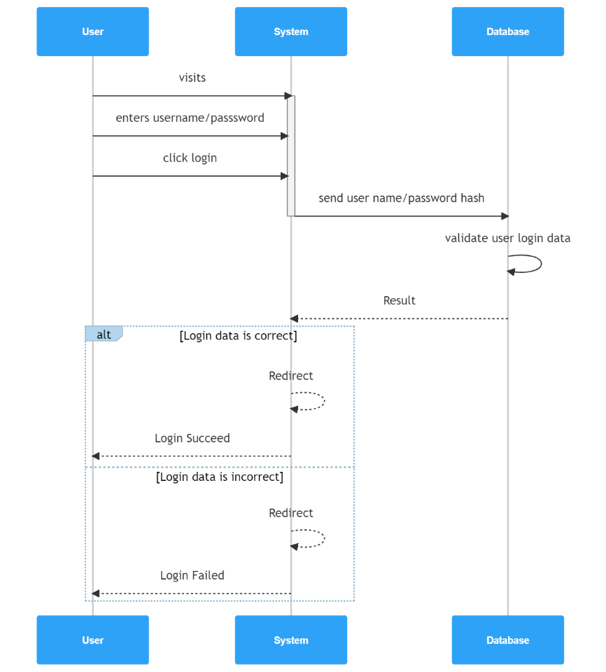

Figure 3.2. Login sequence diagram

### Register

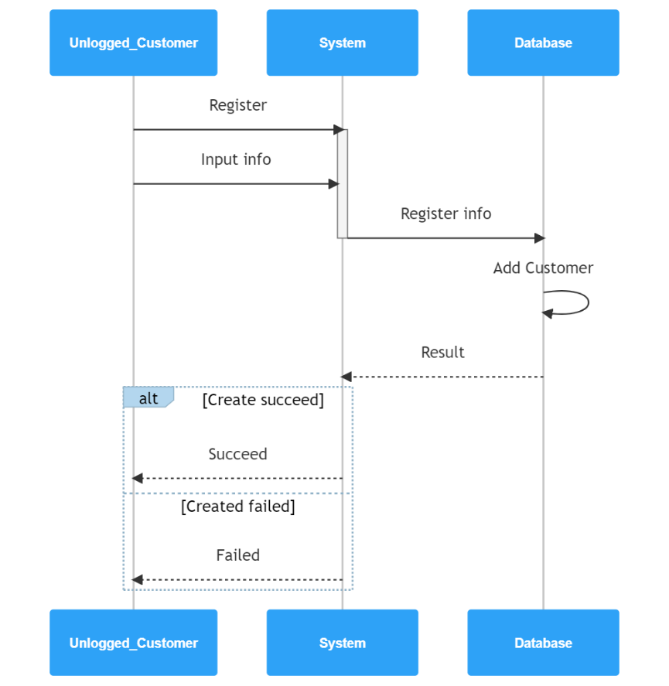

Figure 3.3. Register sequence diagram

### Search

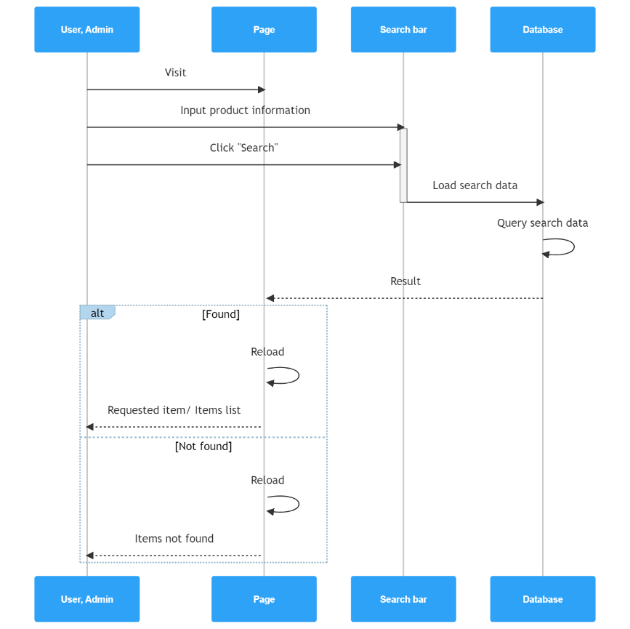

Figure 3.4. Search sequence diagram

### Update user information

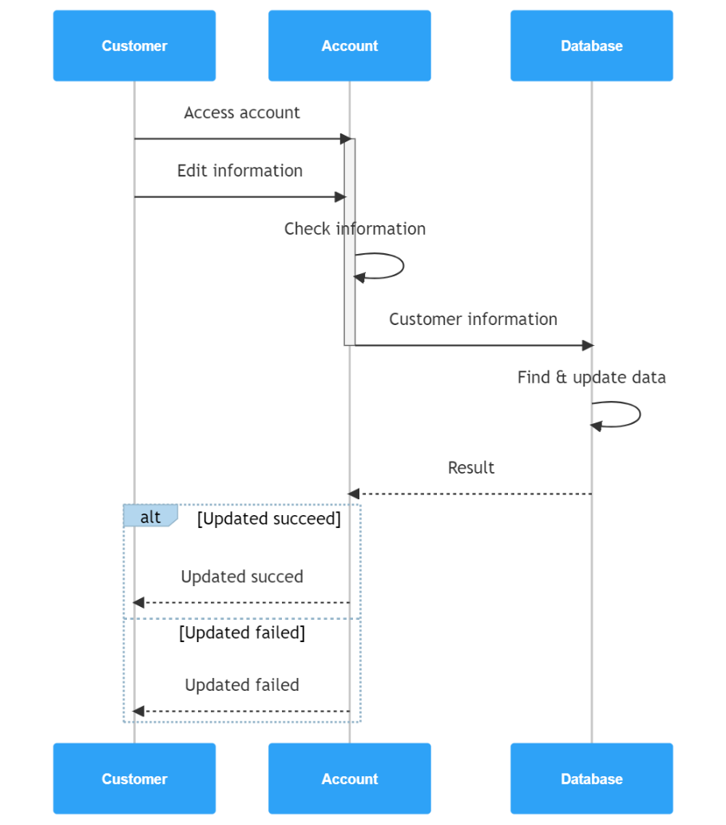

Figure 3.5. Update user information sequence diagram

### Add to cart

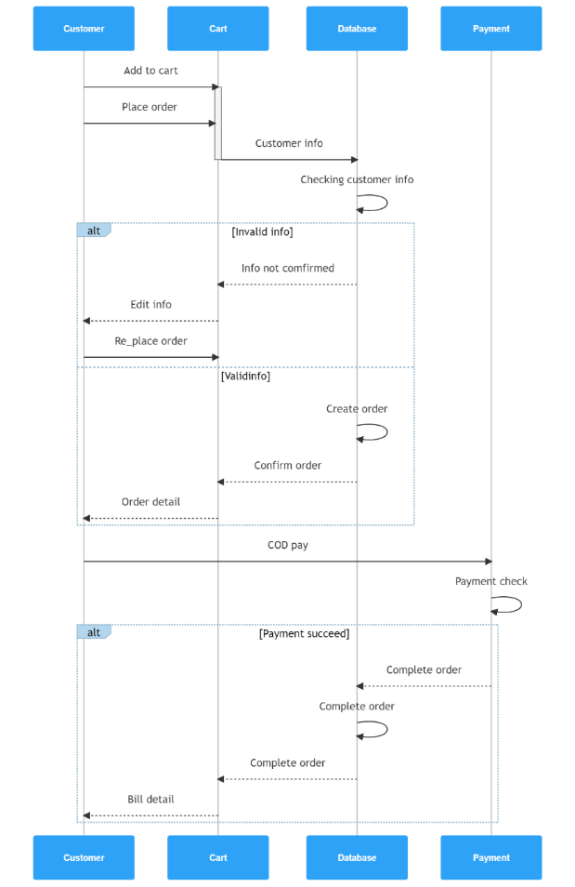

Figure 3.6. Add to cart sequence diagram

### Order management

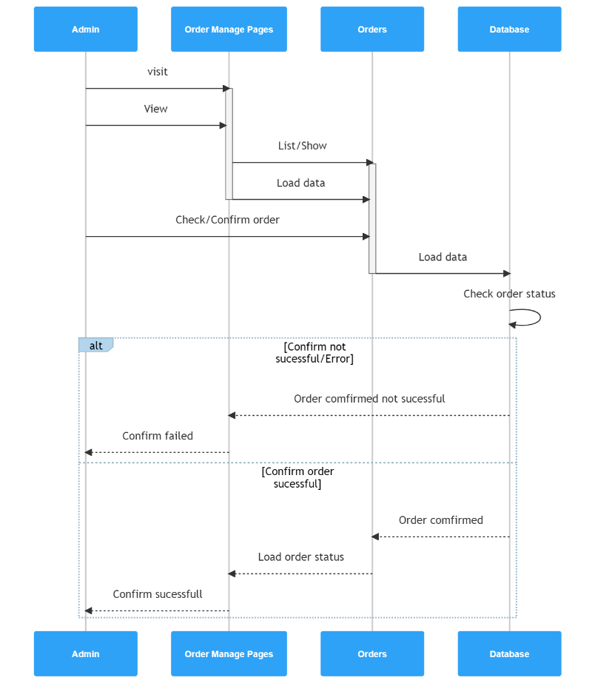

Figure 3.7. Order management sequence diagram

### Product management

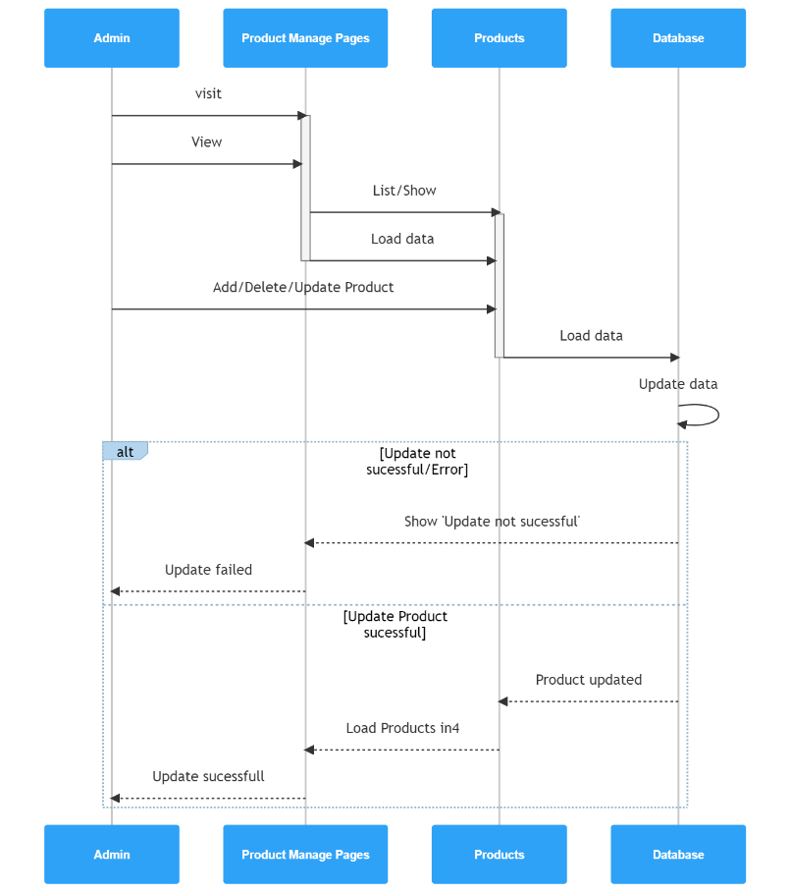

Figure 3.8. Product management sequence diagram

## Entity Relationship Diagram (ERD)

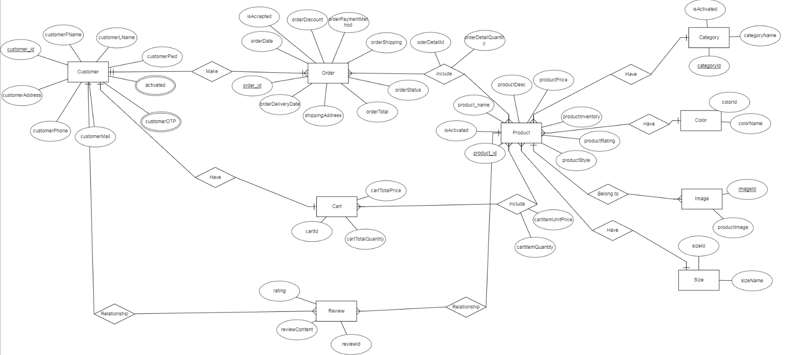

Figure 3.9. Entity relationship diagram

## Class Diagram

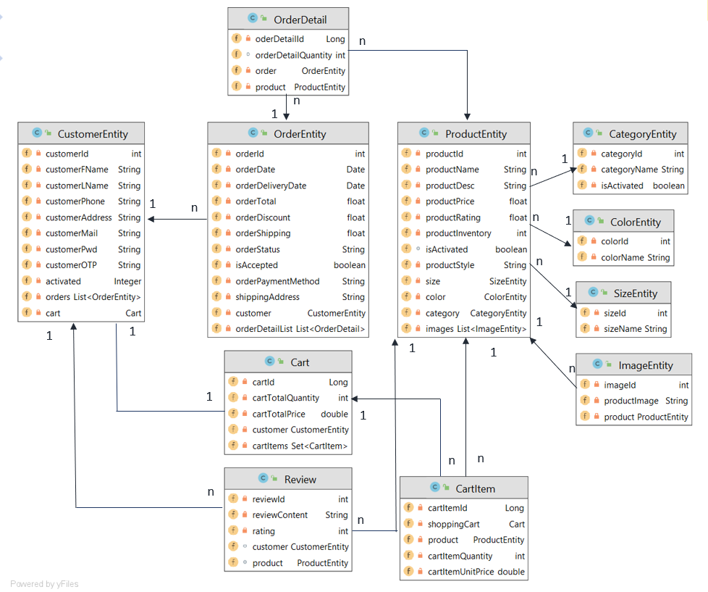

Figure 3.10. Cass diagram

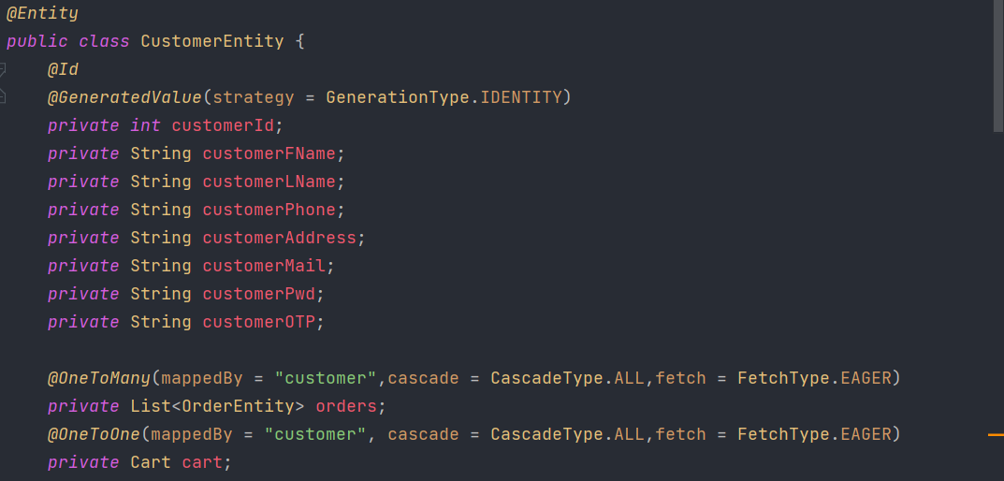

Figure 3.11. Customer model

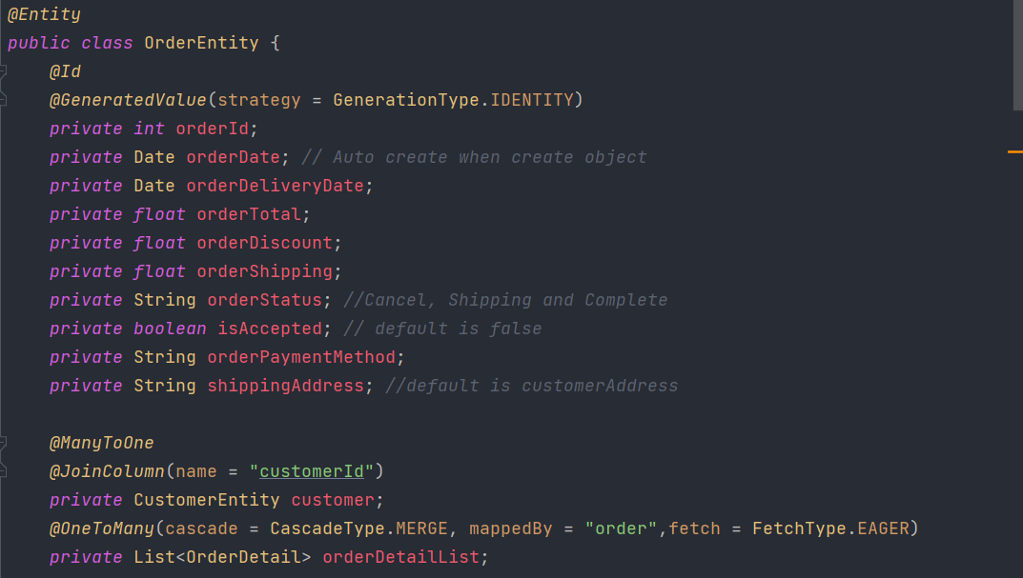

Figure 3.12. Order model

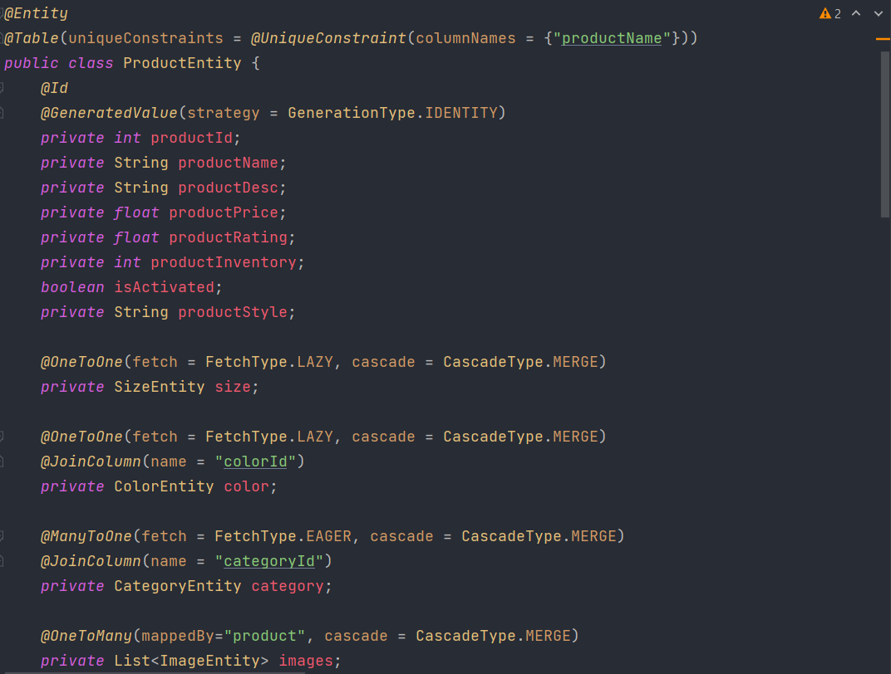

Figure 3.13. Product model

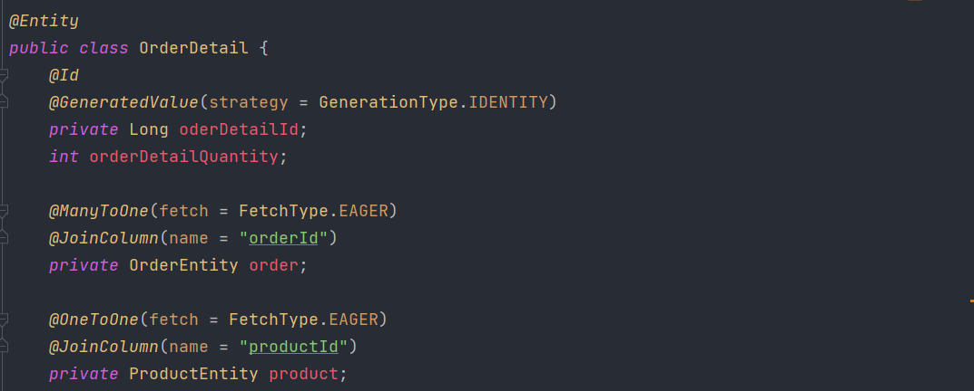

Figure 3.14. Order details model

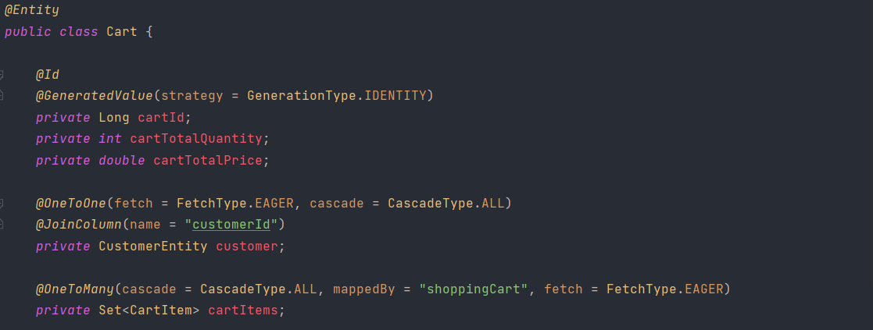

Figure 3.15. Cart model

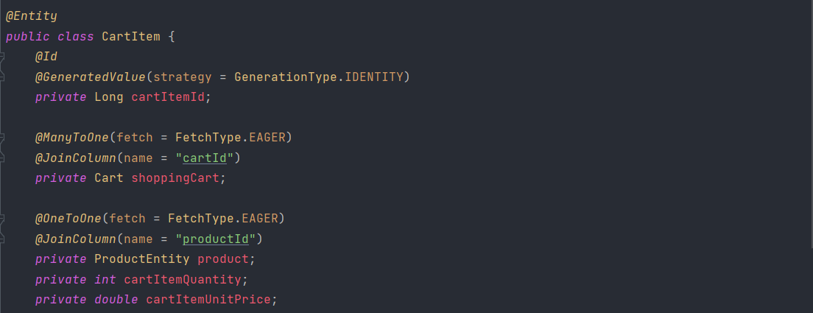

Figure 3.16. Cart item model

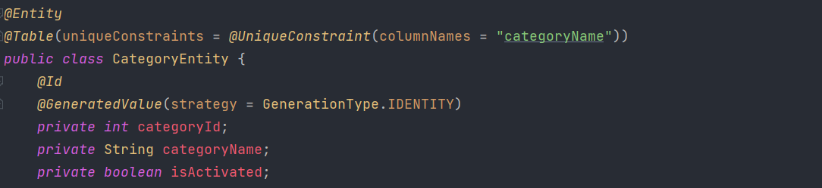

Figure 3.17. Category model

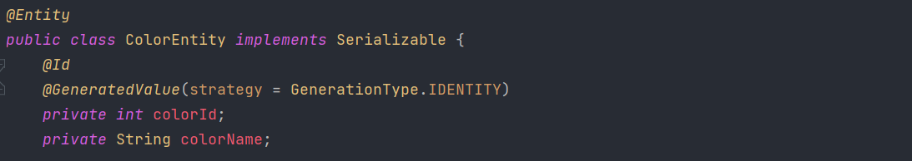

Figure 3.18. Color model

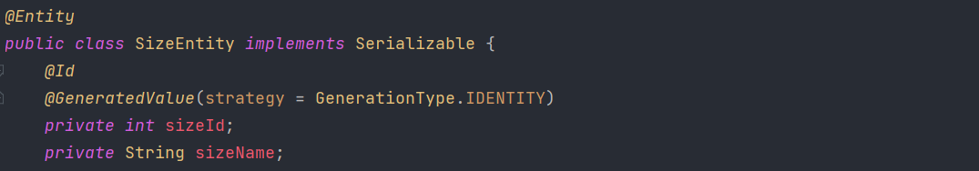

Figure 3.19. Size model

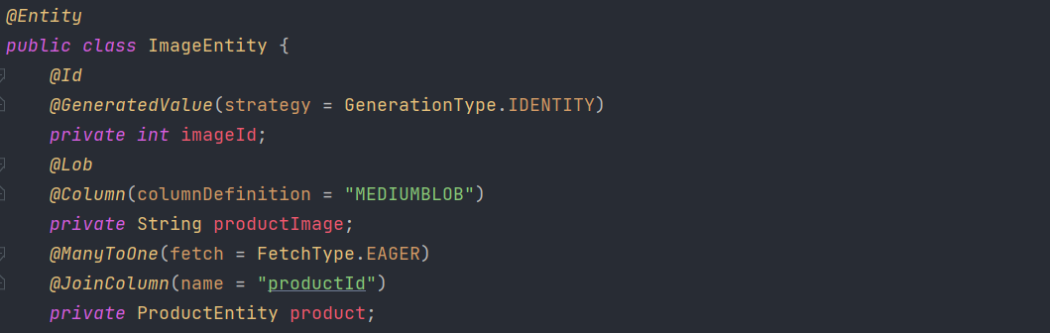

Figure 3.20. Image model

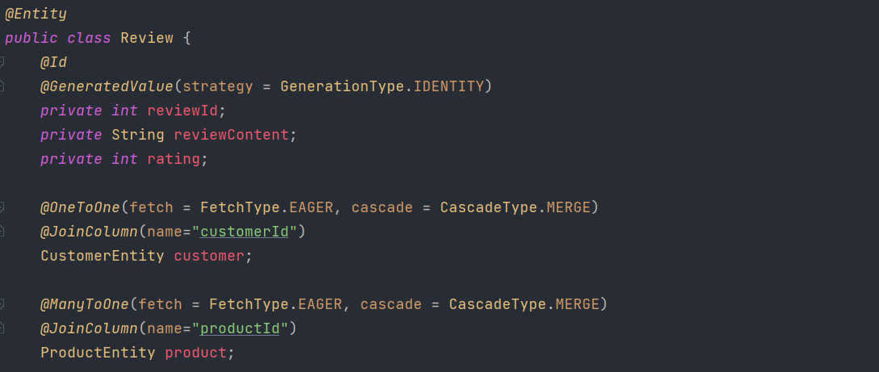

Figure 3.21. Review model

# SYSTEM DESIGN AND IMPLEMENTATION

## Admin page

The admin will take care of the management section, specifically handling products, orders from customers, and product categories. The admin functionality will be developed as a separate project for easier management, running parallel with the customer-related functionalities.

### Views

The approach to solving the Admin section is to have a separate JSP file for each management part. For example, for the "category" section, there will be a "category.jsp" file, and so on.

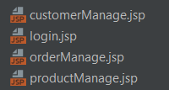

Figure 4.1. Overall admin views

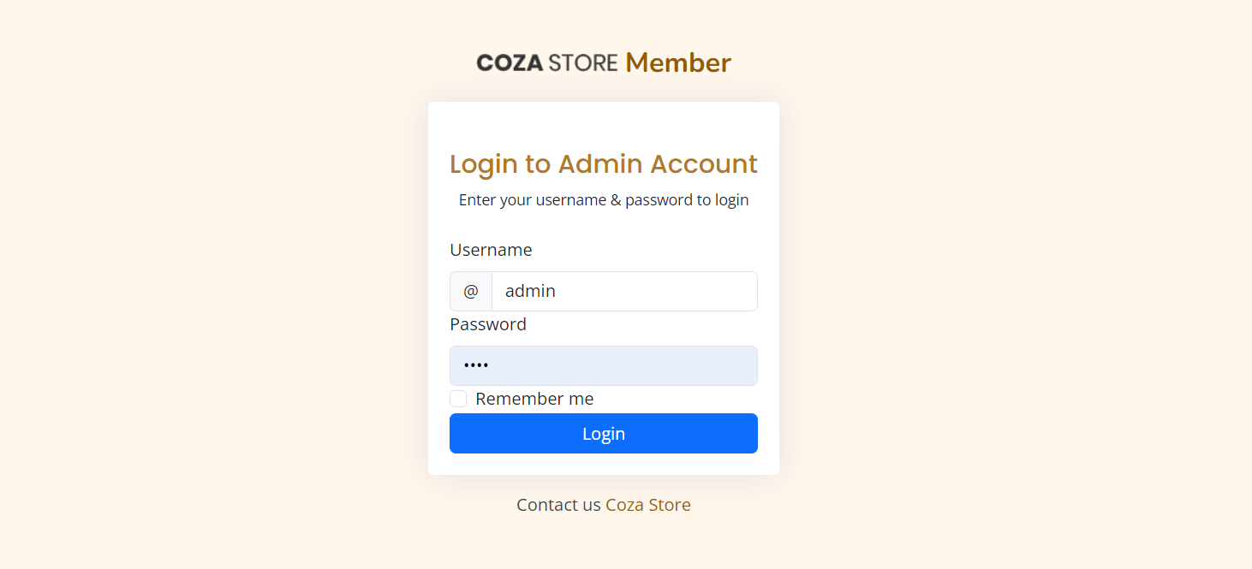

Figure 4.2. Admin login page

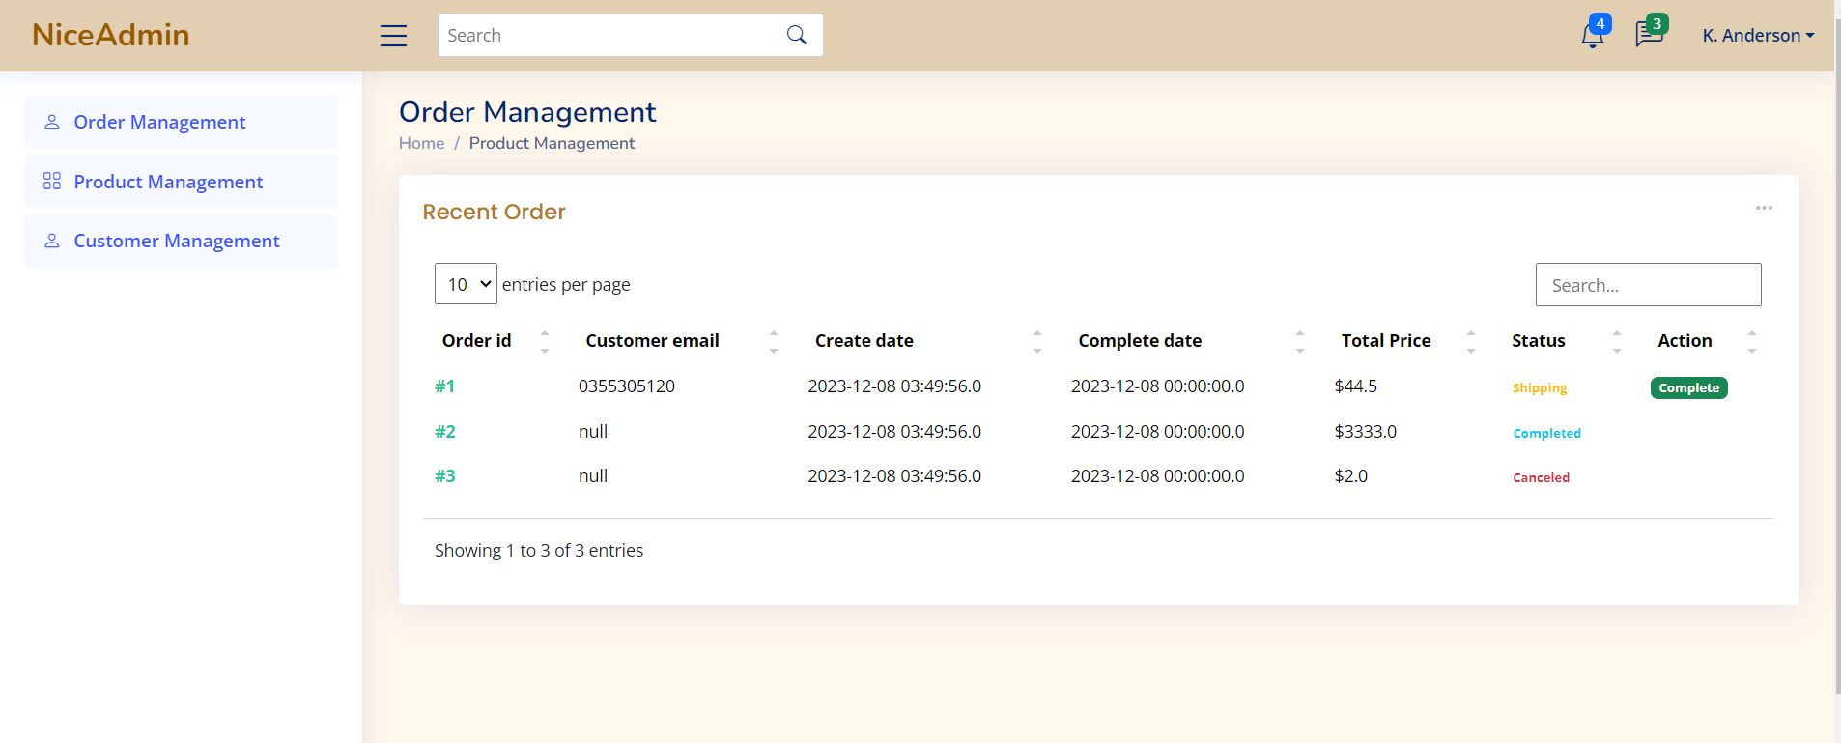

Figure 4.3. Admin order management page

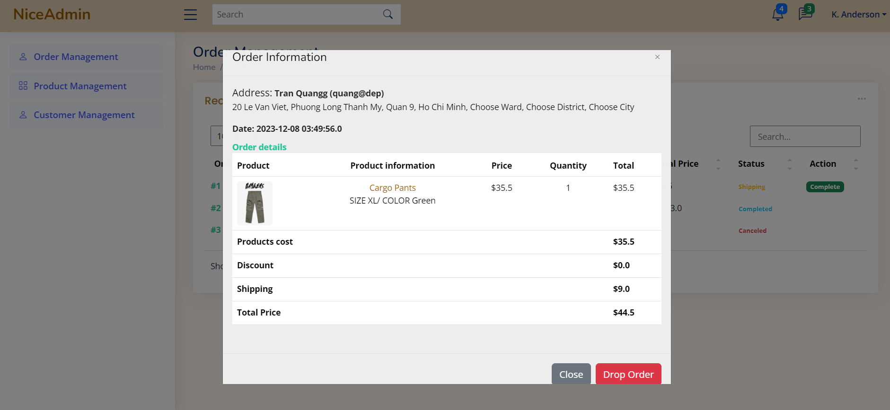

Figure 4.4. Admin order detail

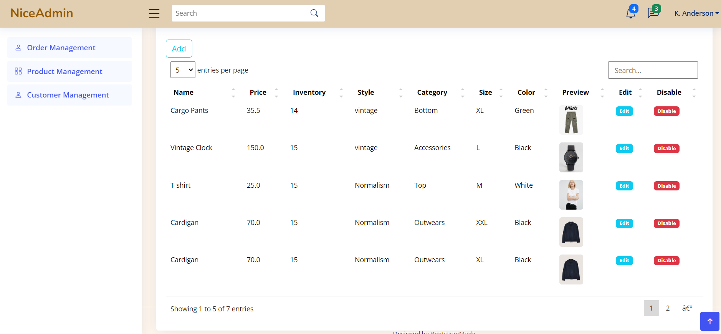

Figure 4.5. Admin product management page

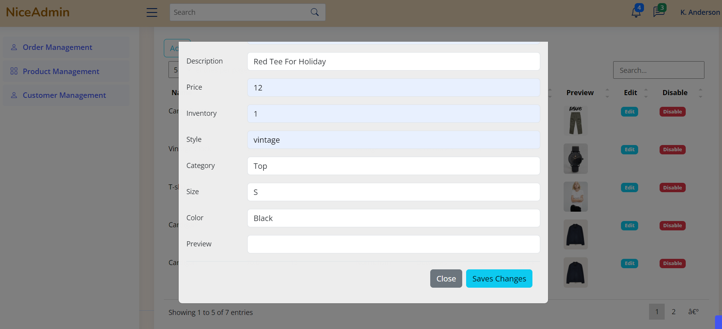

Figure 4.6. Admin add product

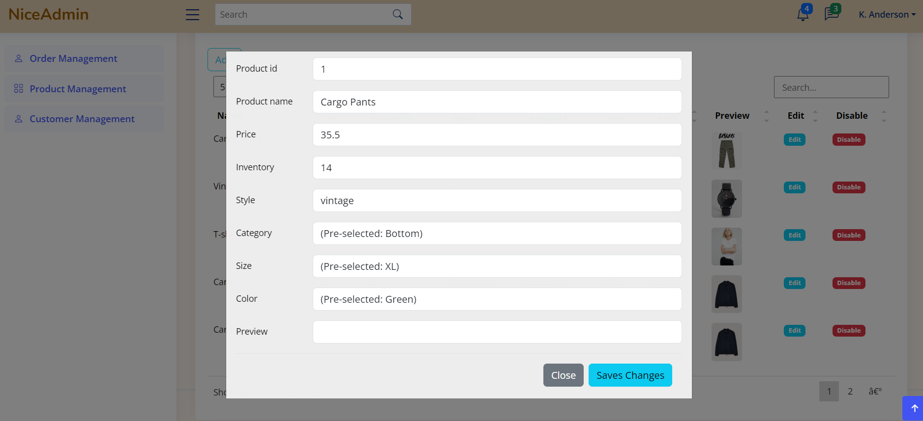

Figure 4.7. Admin edit product

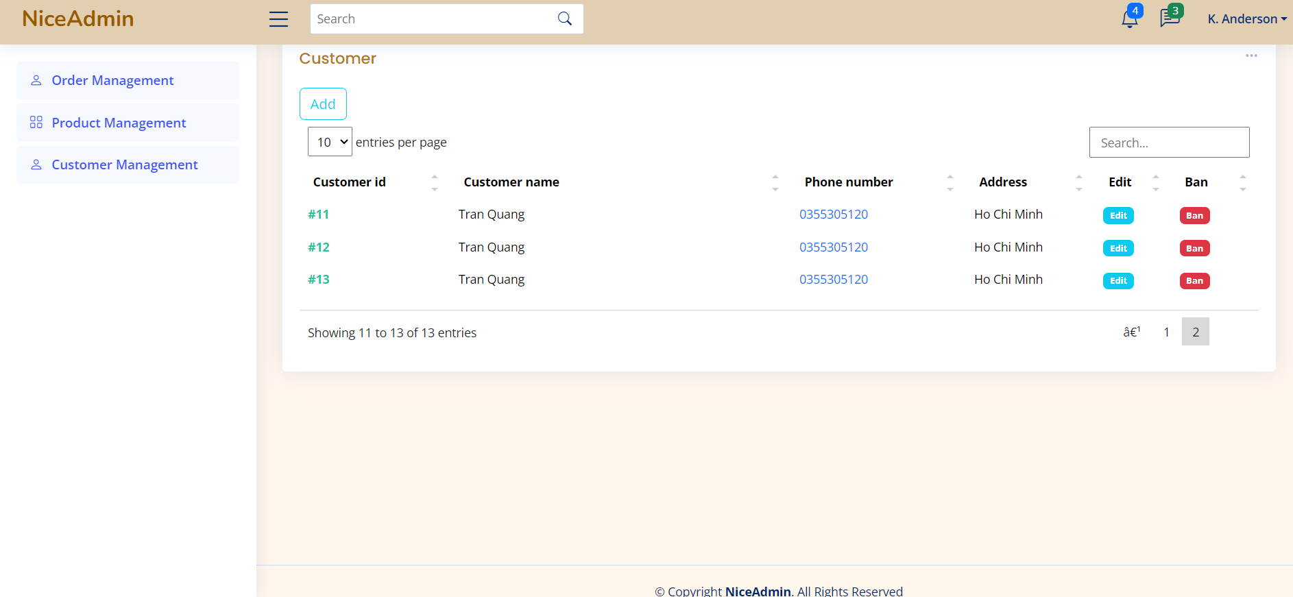

Figure 4.8. Admin customer management view

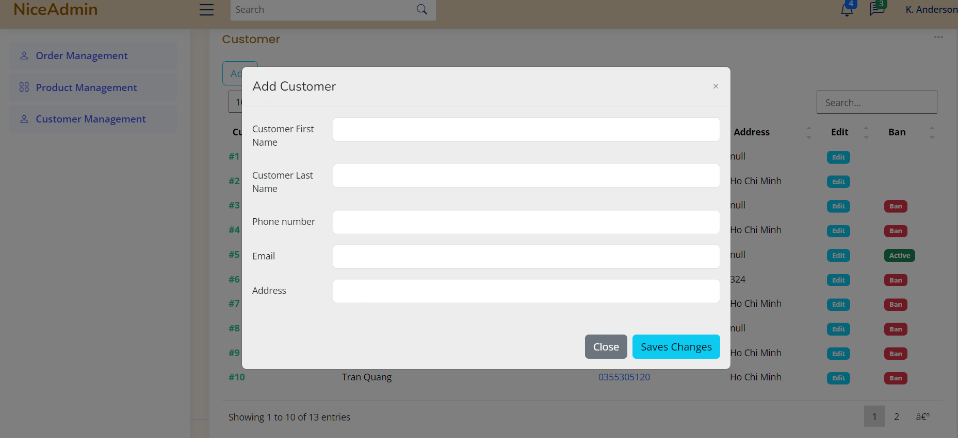

Figure 4.9. Admin add customer

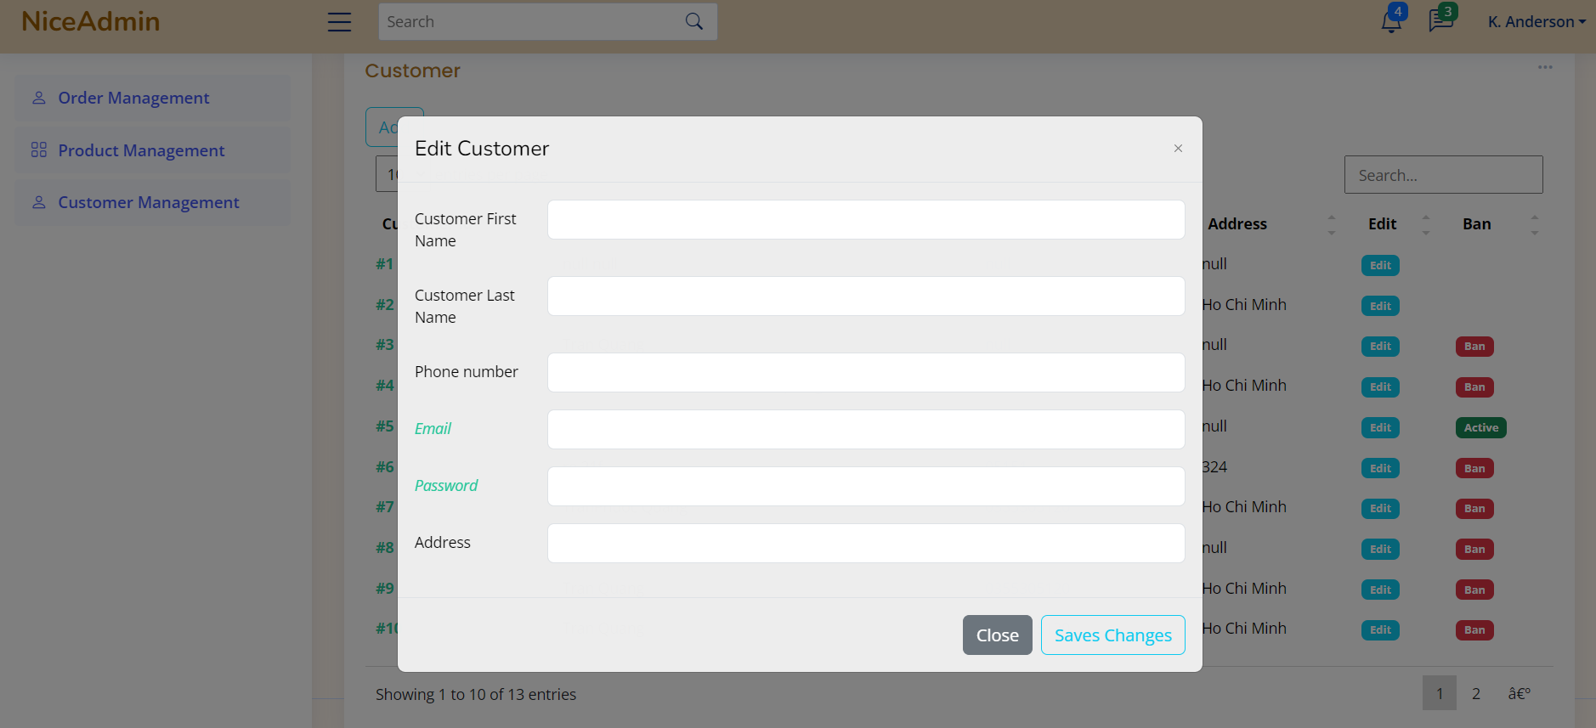

Figure 4.10. Admin edit customer information

### Controller

To facilitate data input or retrieval from the JSP files, we establish separate controller files for each management section to handle requests.

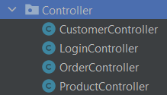

Figure 4.11. Overal adminl controller

#### Login Controller

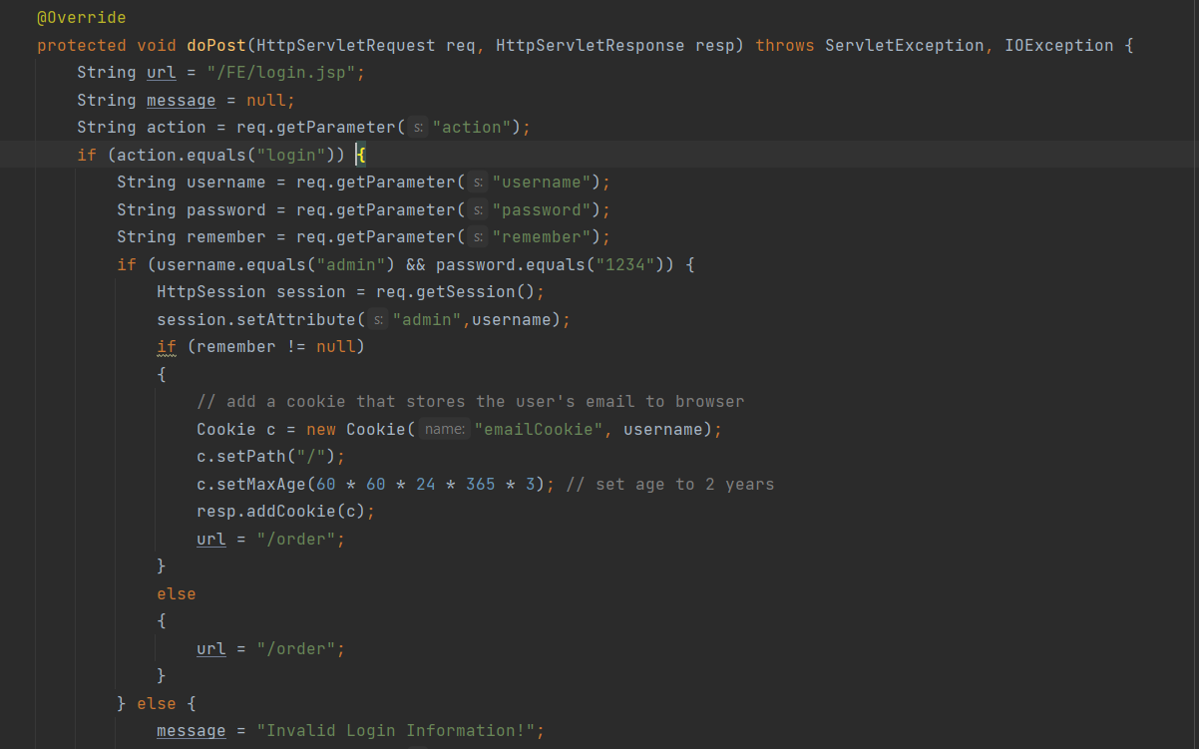

Figure 4.12. Login controller function

This Controller will handle the admin login functionality. It will receive a request with two values: the *username* and *password* entered by the admin. If the username is 'admin' and the password is '1234', the controller will redirect the request to the 'index.jsp' page. If the credentials are incorrect, it will generate an error and redirect to ‘/order’ which prepares order for Order Managements Pages.

#### Order Controller

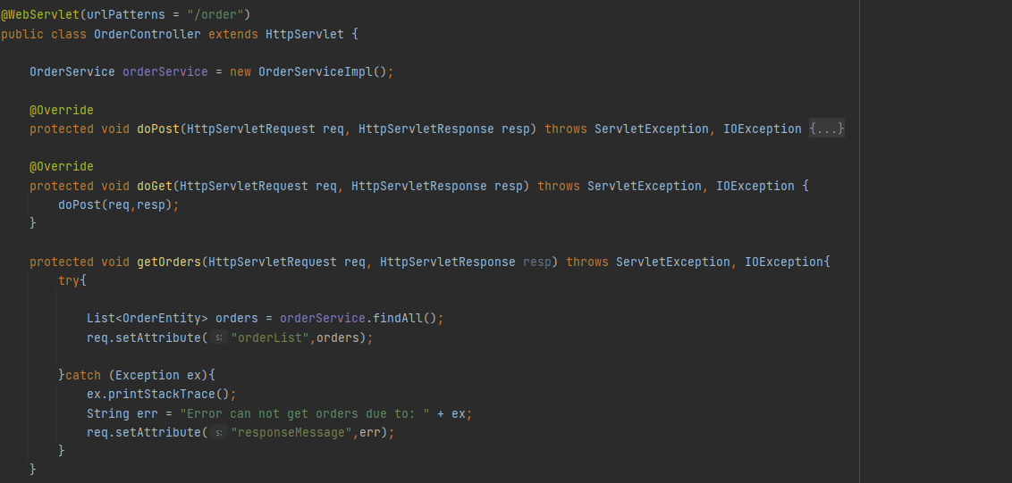

Figure 4.13. Order controller function

Table 4.1. Order controller description

|  |  |
| --- | --- |
| Method name | Description |
| getOrders | It retrieves a list of orders from some service (orderService), sets this list as an attribute in the request for further processing, and handles any exceptions that may occur during this process.  If an exception occurs, an error message is set as a request attribute for potential display or logging. |
| modifyOrders | This method is likely used to modify orders based on different actions such as confirming, completing, or canceling an order.  It extracts necessary information from the request, performs the specified modification, updates the order, and sets a success or error message in the request attributes. |

#### Product Controller

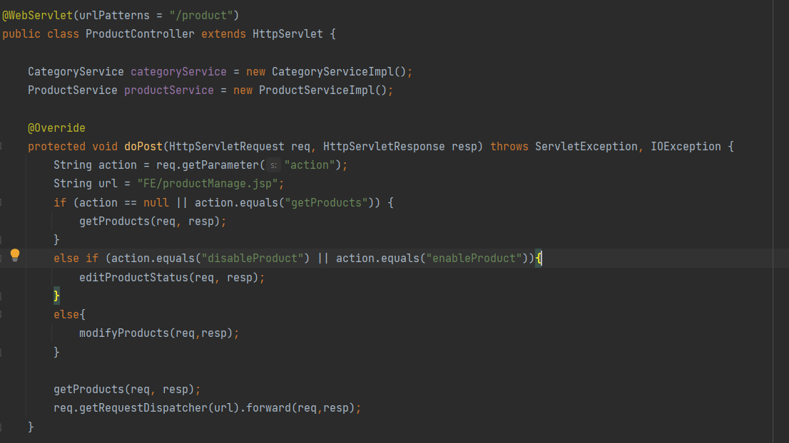

Figure 4.14. Product controller function

Table 4.2. Product controller function description

|  |  |
| --- | --- |
| Method name | Description |
| getProducts | This method is likely used to retrieve information about products, categories, sizes, and colors from corresponding services.  It sets these lists as attributes in the request, making them available for processing in the subsequent stages of request handling.  In case of an exception, it prints the stack trace and provides an error message as a request attribute. |
| editProductStatus | This method likely handles requests to edit the activation status of a product (enable or disable).  It extracts parameters from the request, checks if the product exists, updates its activation status, and sets a success or error message in the request attributes.  The activation status change is then persisted using the update method of the productService. |
| modifyProducts | This method will be executed when we want to edit the information of a category. It will return the details of the product that we want to edit and display them in a form presented in the JSP file. |

#### Customer Controller

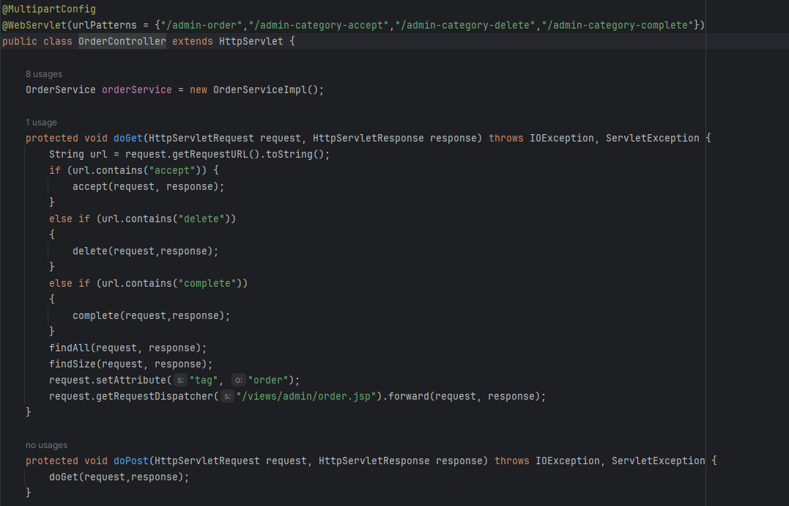

Figure 4.15. Customer controller function

Table 4.3. Customer controller functio description

|  |  |
| --- | --- |
| Method name | Description |
| accept | This method will be executed when we accept an order. The order is made by customer, then admin will be resposible for accept order or not. If the order is accepted, its delivery date is set to the date when the order is created plus an additional 5 days and status will be set as “shipping” |
| addCustomers | This method likely handles requests to add a new customer to the This method likely handles requests to add a new customer to the system.  It extracts customer details from the request, creates a new CustomerEntity with the provided information, and adds this new customer to the system using the insert method of the customerService.  In case of an exception, it prints the stack trace and provides an error message in the request attributes. |
| getCustomers | This code snippet might be used to populate a customer list for display on a web page or for further processing in the application.  The error handling in the catch block ensures that if an exception occurs during the data retrieval process, it is logged, and an error message is made available in the request attributes for potential display or logging. |
| editCustomers | This method likely handles requests to edit customer information.  It extracts customer details from the request, creates a new CustomerEntity with updated information, and updates the customer information in the system using the update method of the customerService.  In case of an exception, it prints the stack trace and provides an error message in the request attributes. |
| banCustomers/  activeCustomers | This method likely handles requests to activate a customer account. |

### Service

In this project, we adopt an interface service - a structure that outlines methods, coupled with a Java class, "serviceimpl," to execute those methods within the service interface. This approach enhances our ability to effectively manage tasks that interact with model rather than interact directly from Controller.

## Customer page

### Views

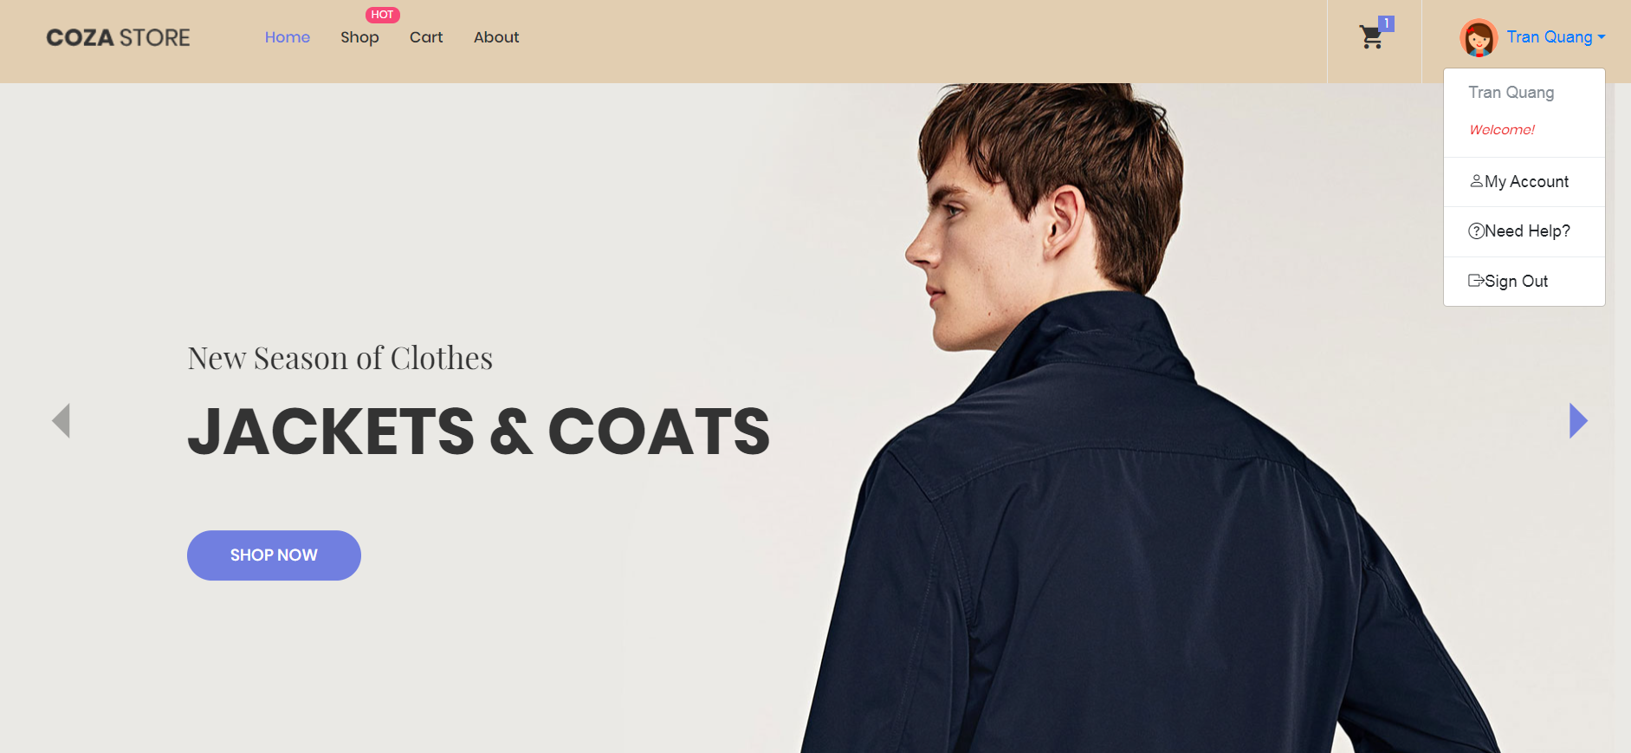

Figure 4.16. Customer home page

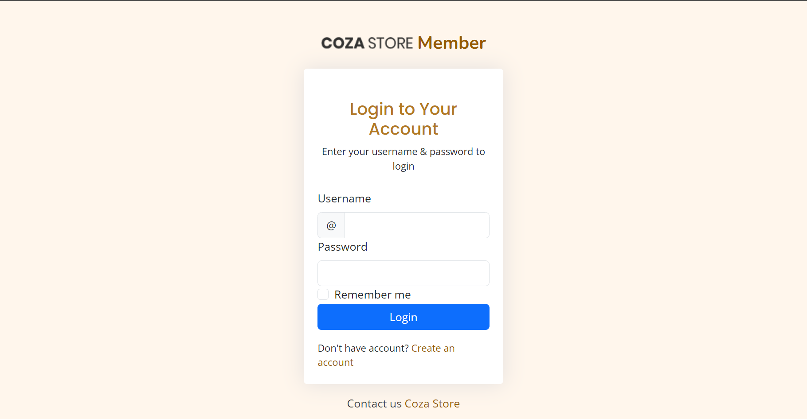

Figure 4.17. Customer login page

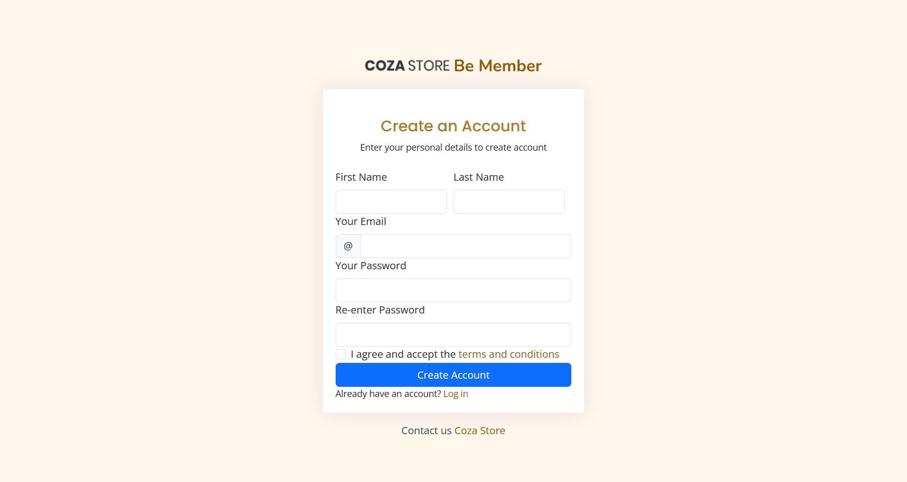

Figure 4.18. Customer register page

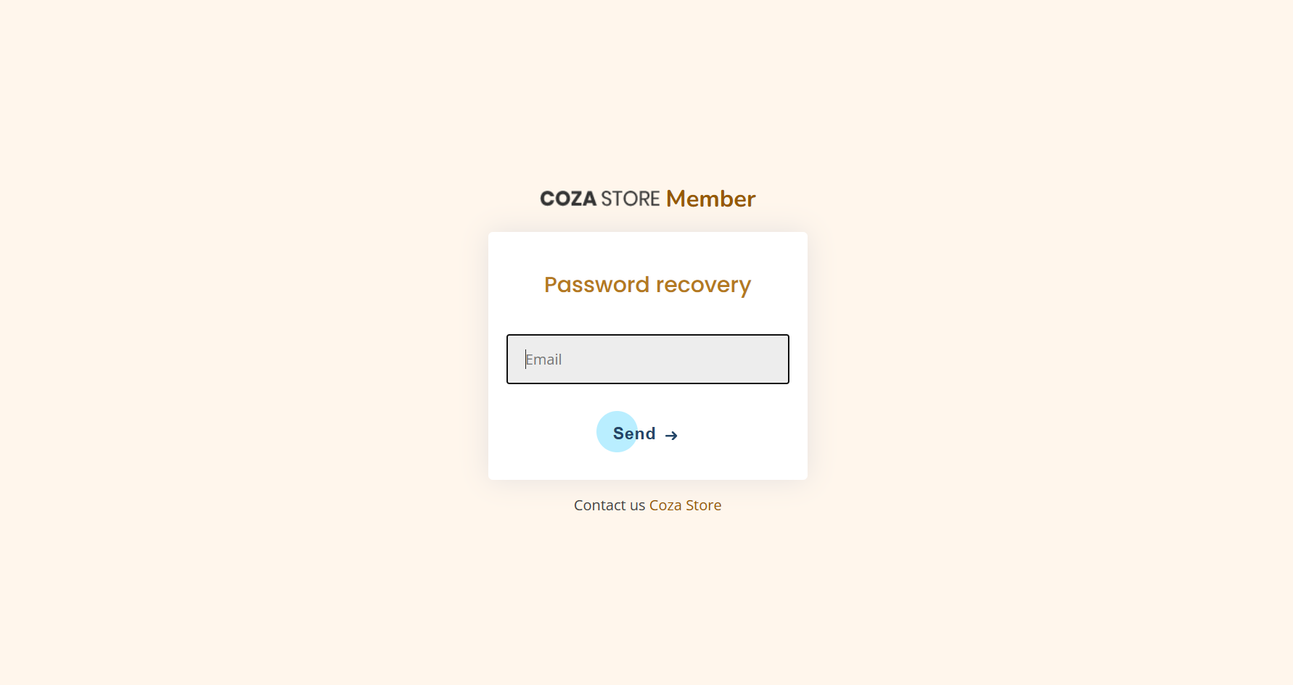

Figure 4.19. Customer forgot password page

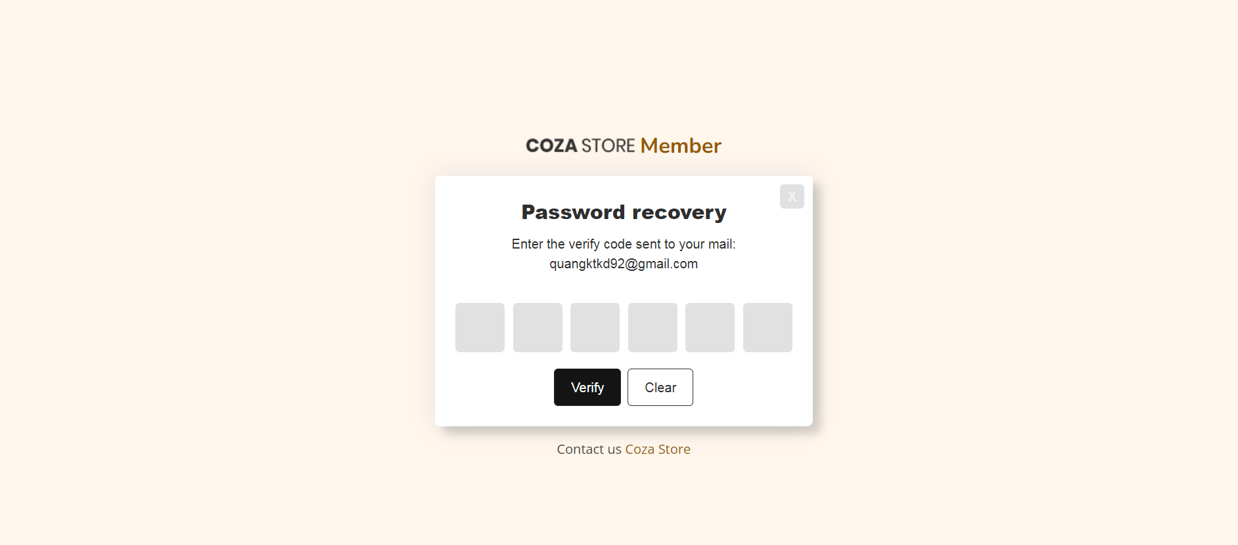

Figure 4.20. Customer insert OTP page

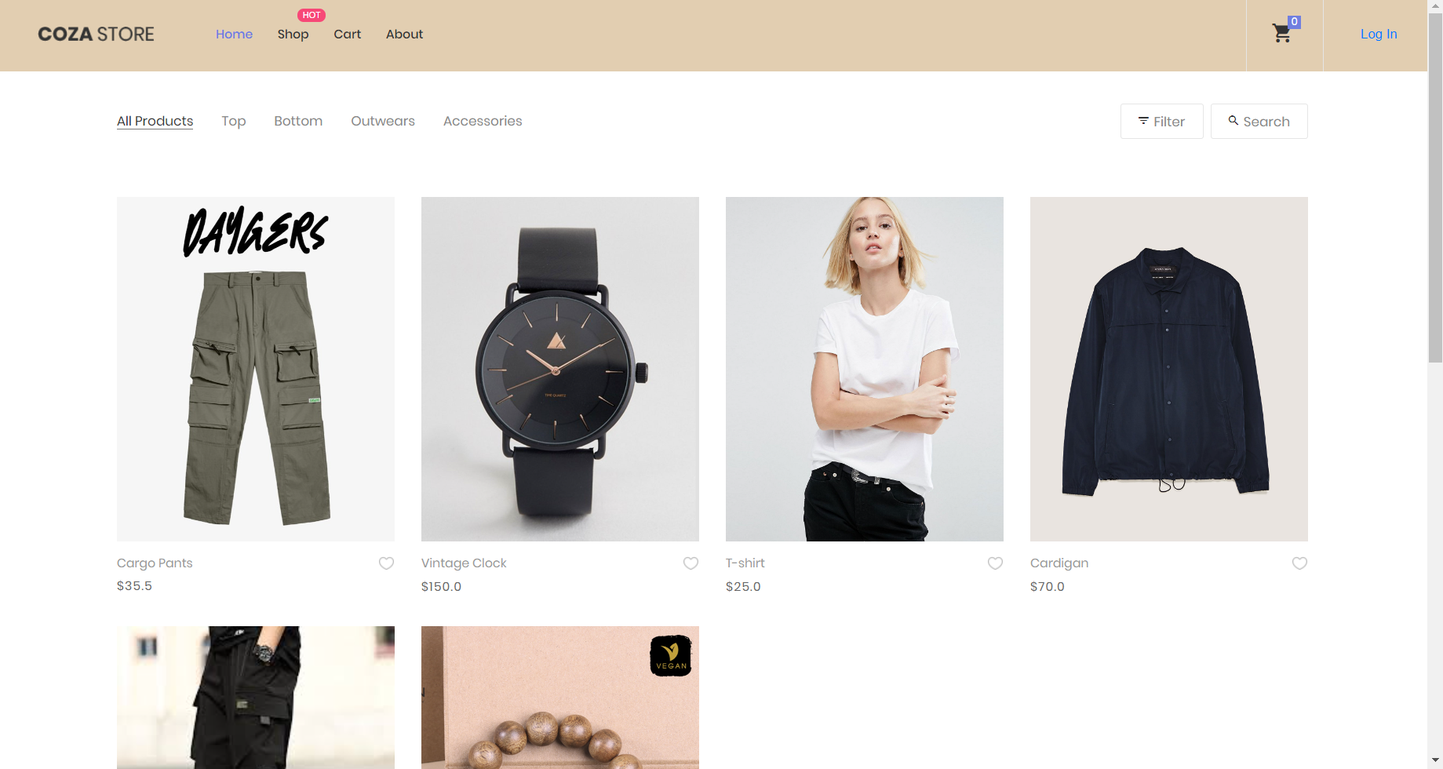

Figure 4.21. Customer product page

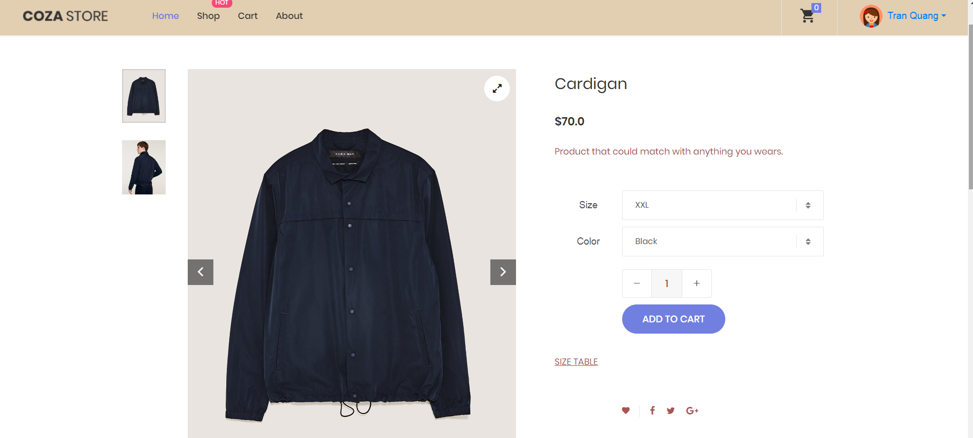

Figure 4.22. Customer product details page

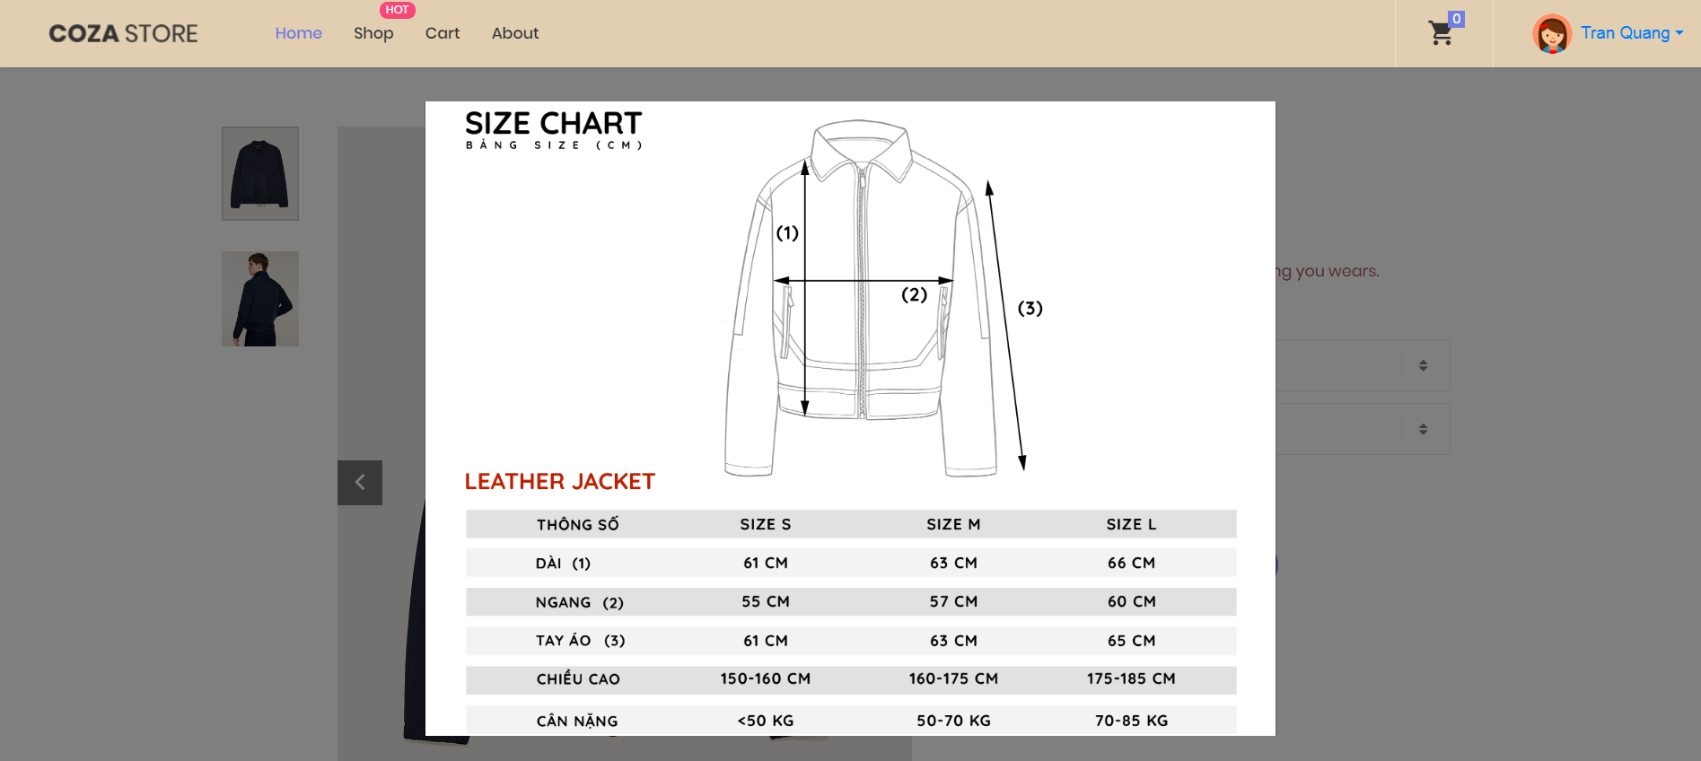

Figure 4.23. Size table page

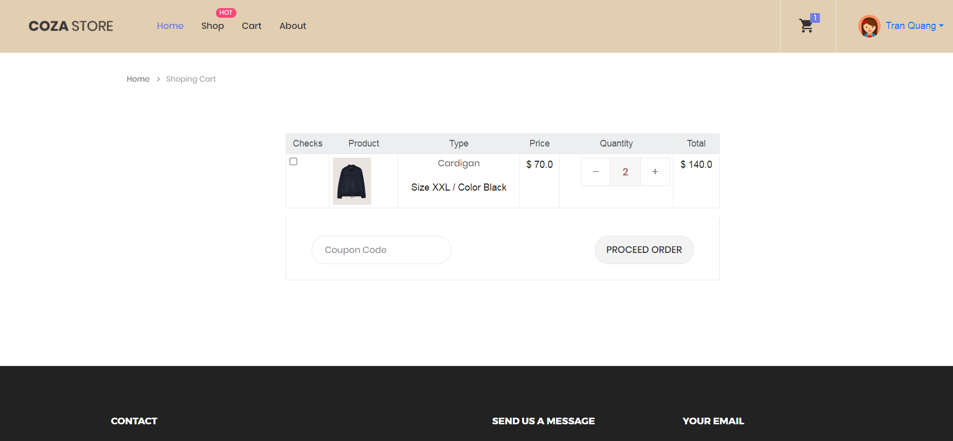

Figure 4.24. Customer cart page

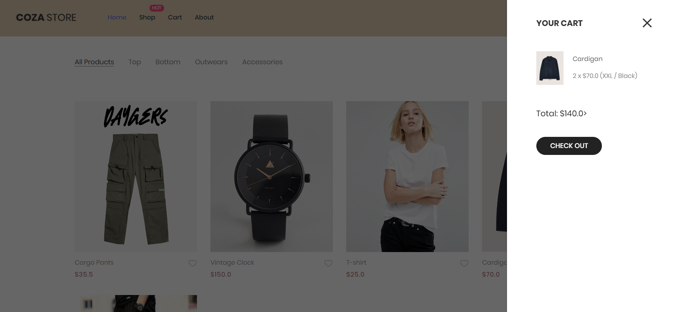

Figure 4.25. Customer mini cart

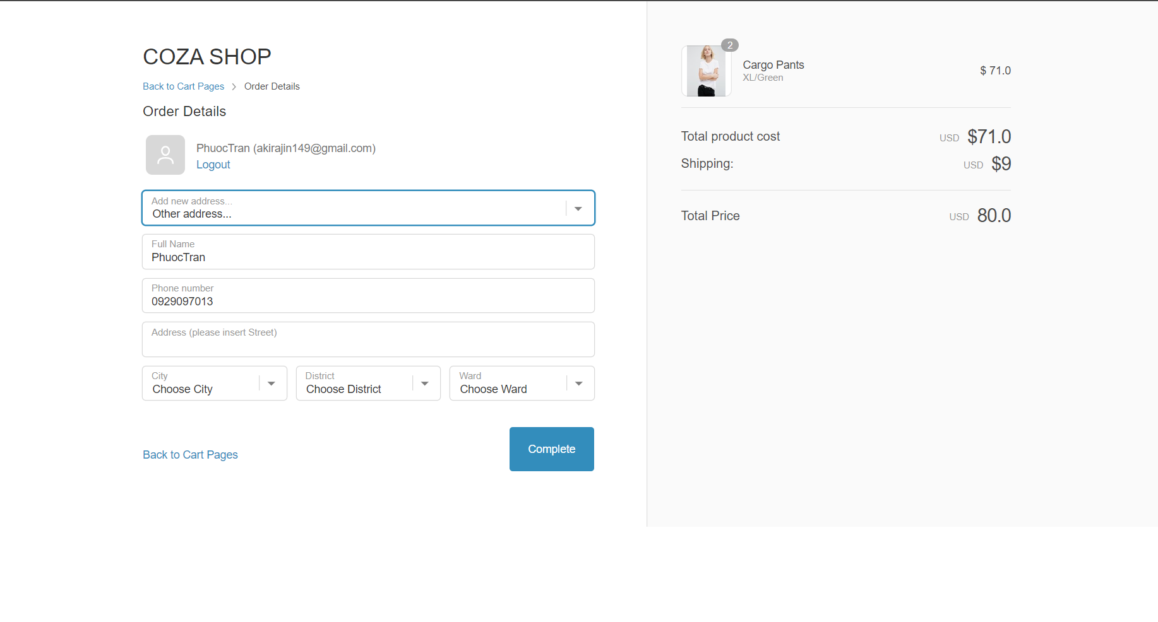

Figure 4.26. Order confirmation page

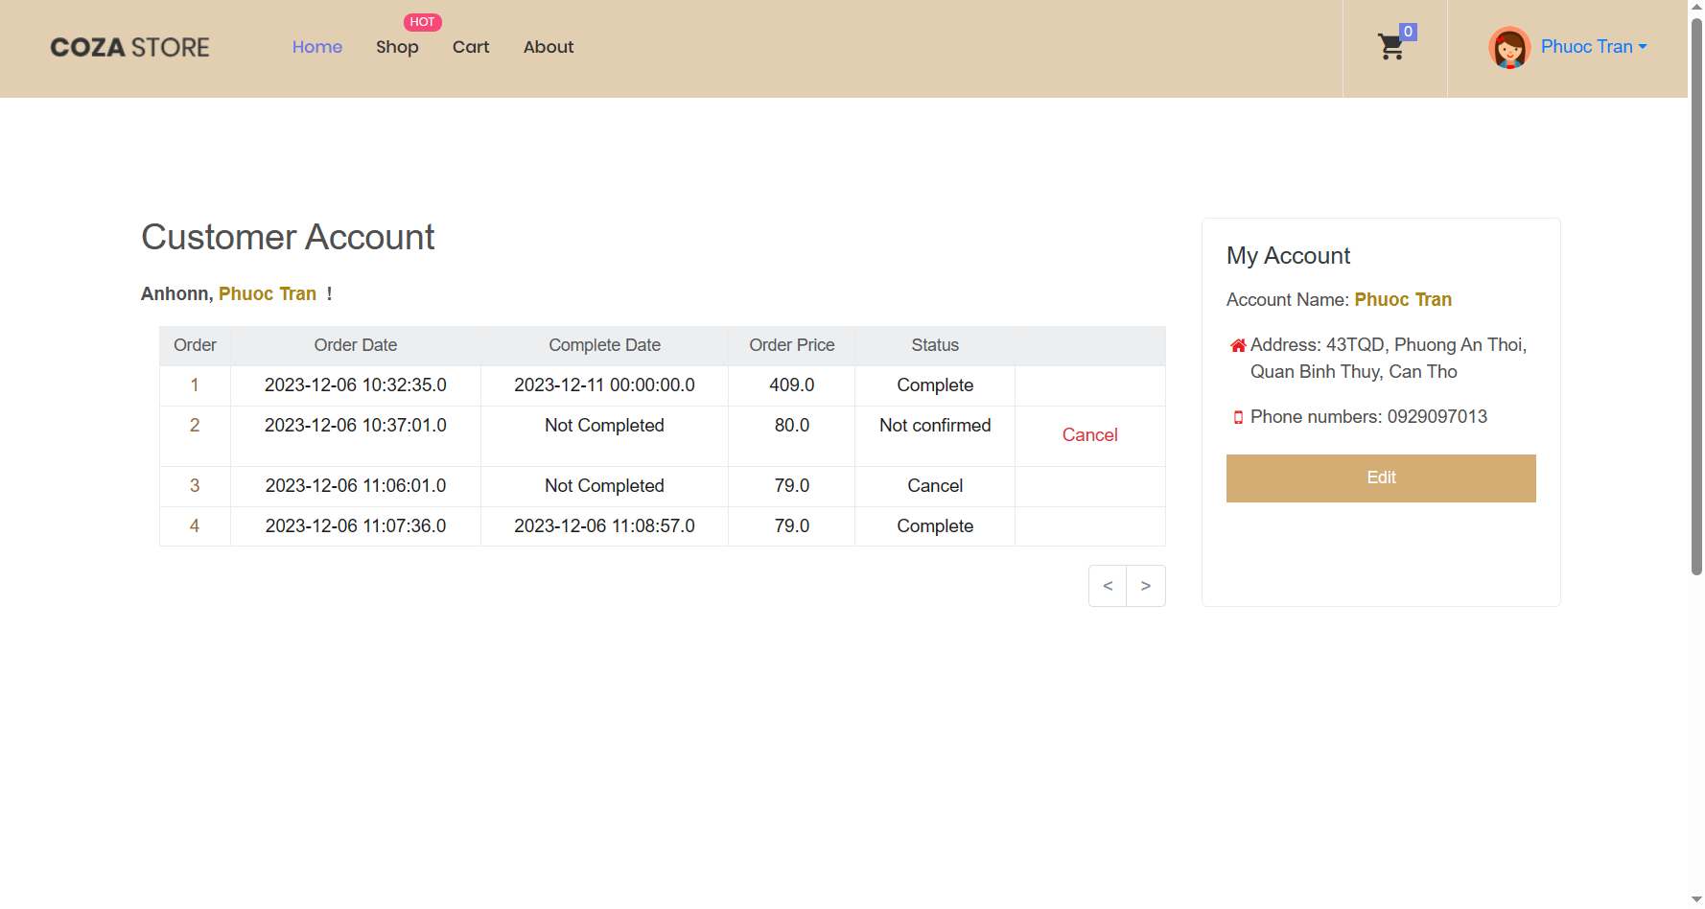

Figure 4.27. Customer account page

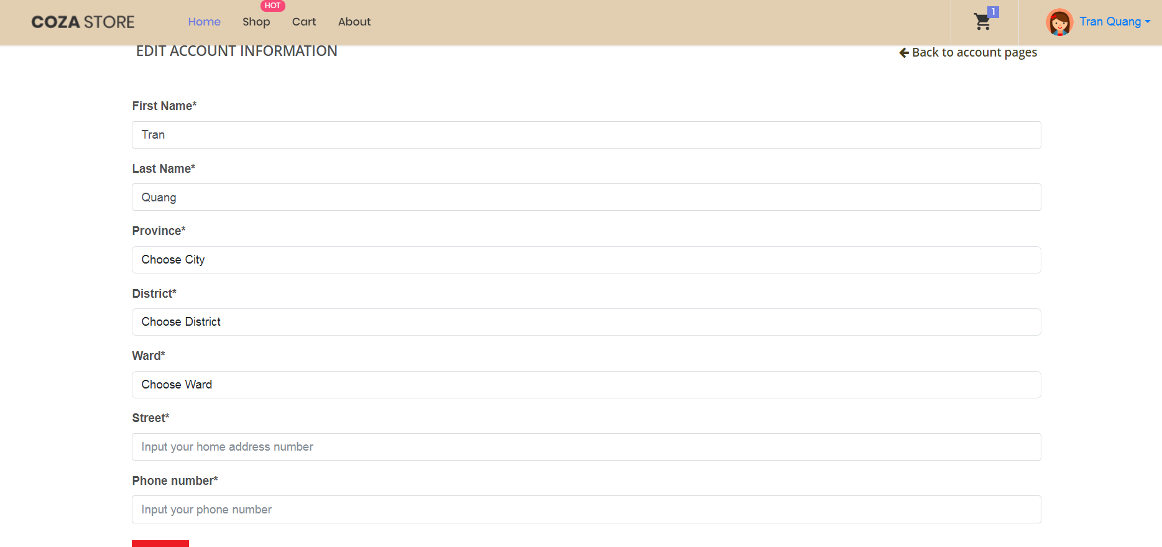

Figure 4.28. Customer edit information page

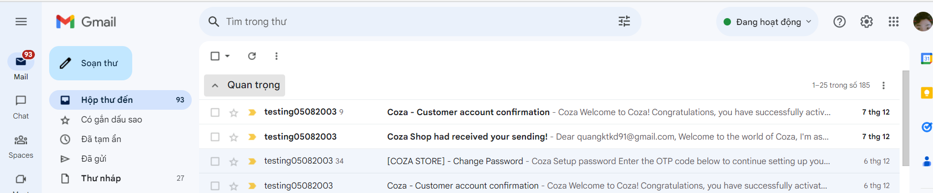

Figure 4.29. Email sending

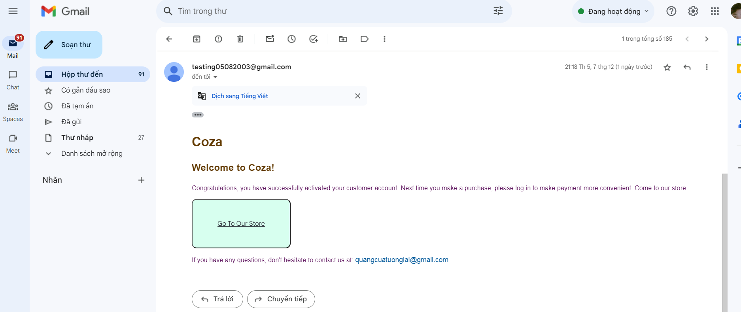

Figure 4.30. Register account email

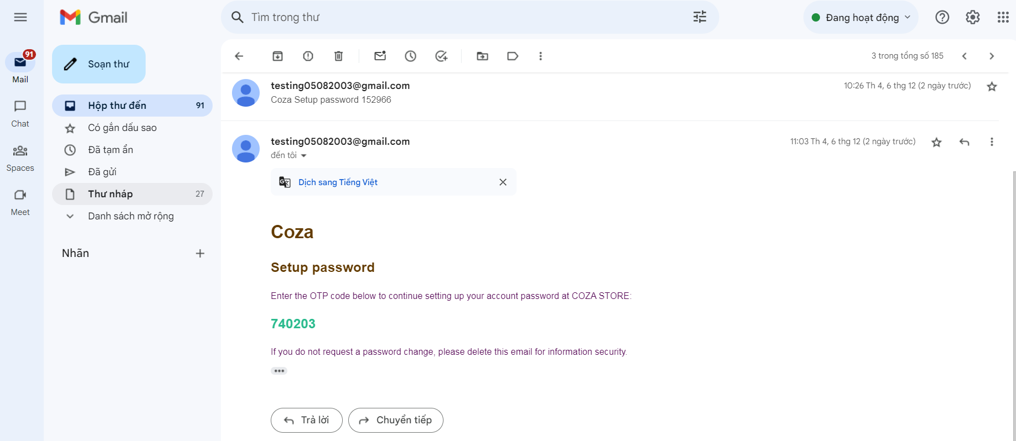

Figure 4.31. Forgot password email

### Controller

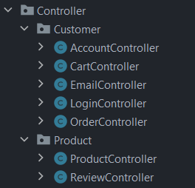

Figure 4.32. Customer overall controller

#### Account Controller

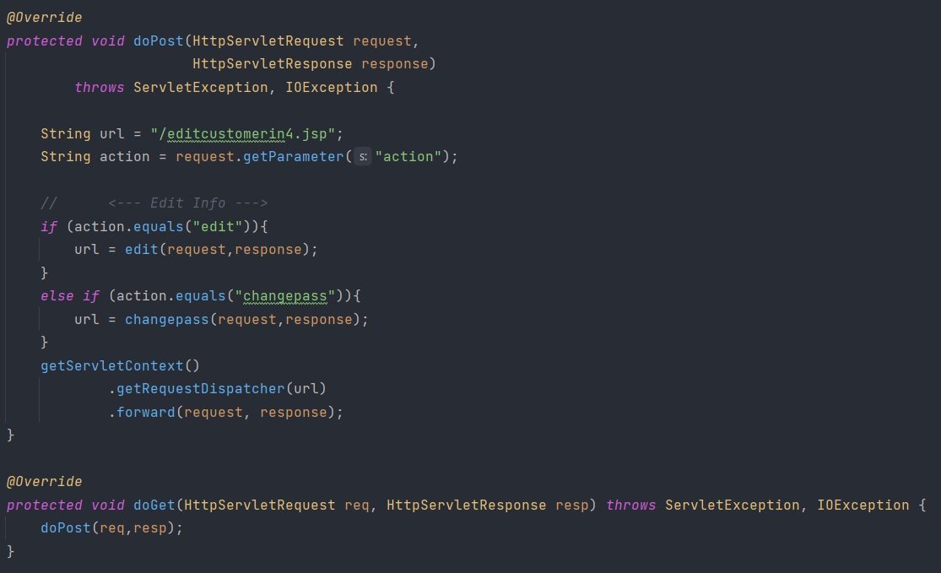

Figure 4.33. Customer account controller function

Table 4.4. Customer account controller description

|  |  |
| --- | --- |
| Method name | Description |
| edit | Handle update user information function with provided info from JSP page. |
| changepass | Handles the process of changing the user's password. |

#### Cart Controller

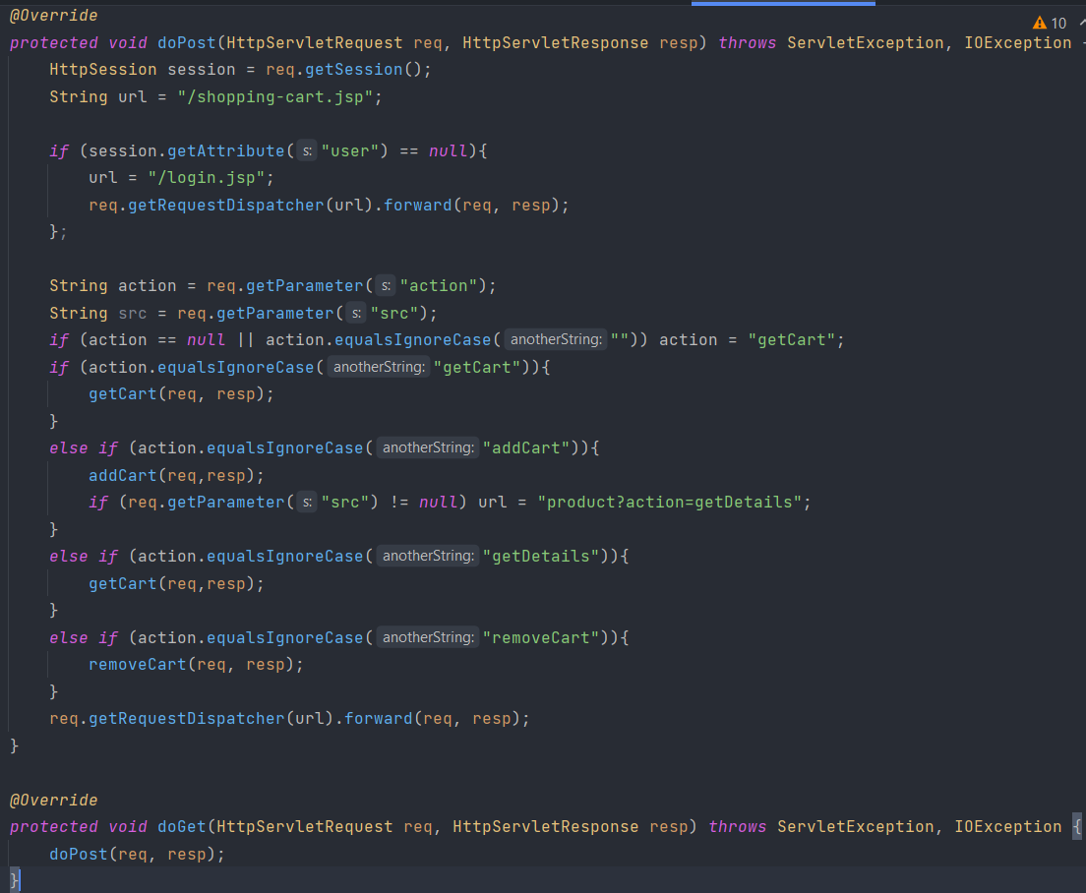

Figure 4.34. Customer cart controller function

Table 4.5. Customer cart controller function description

|  |  |
| --- | --- |
| Method name | Description |
| getCart | Retrieves the user's cart and associated cart items from the database based on the user session.  This is a Public Static method which means it can be call anywhere in the project due to the needs of updated rapidly through out the session of the cart. |
| addCart | Updates the cart by either adding a new item or modify the quantity of an existing item (if an item quantity is less than or equal 0 it will be removed from the cart). |
| removeCart | Manages the removal of items from the cart by id and increases the product inventory back by the removed quantity. |

#### Email Controller

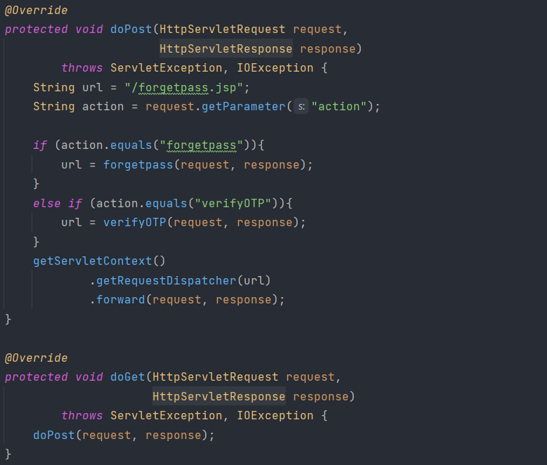

Figure 4.35. Customer forgot password function

Table 4.6. Customer forgot password function description

|  |  |
| --- | --- |
| Method name | Description |
| forgetpass | Processes the forget password action by generate an OTP that sending to email and required user to input and compare OTP before password can be changed. |
| verifyOTP | Handles OTP verification. Retrieves the OTP entered by the user and compares it with the OTP stored in the customer's entity. |

#### Login Controller

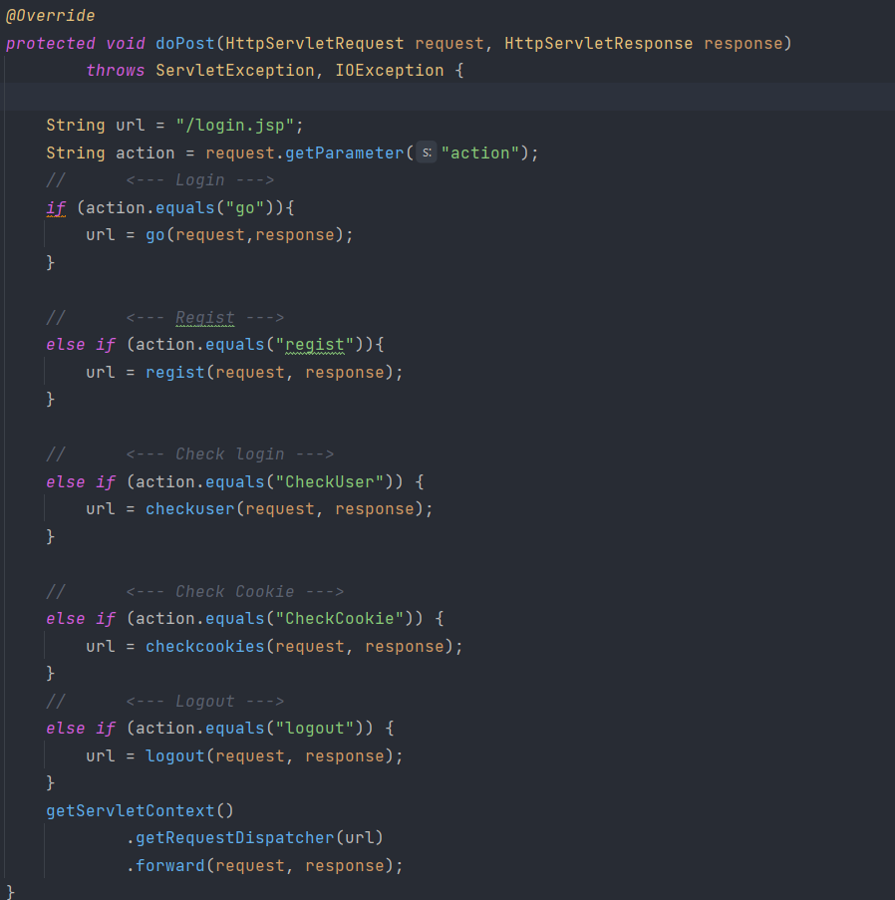

Figure 4.36. Customer logn controller function

Table 4.7. Customer logn controller function description

|  |  |
| --- | --- |
| Method name | Description |
| go | Processes user login.  Validates the user's credentials against the database.  If successful, sets a session attribute for the user and potentially creates a cookie if "remember" is selected. |
| regist | Handles user registration.  Persists new customer information into the database.  Sends a confirmation email to the registered email address. |
| checkUser | Checks if a user is logged in.  If the user is not logged in, checks for an email cookie. If found, retrieves user information and sets a session attribute. |
| checkCookie | Checks for user cookies.  Retrieves user information from cookies and sets a session attribute if the user is not logged in. |
| logout | Handles user logout functionality.  Deletes cookies associated with the user and invalidates the session. |

#### Order Controller

#### Product Controller

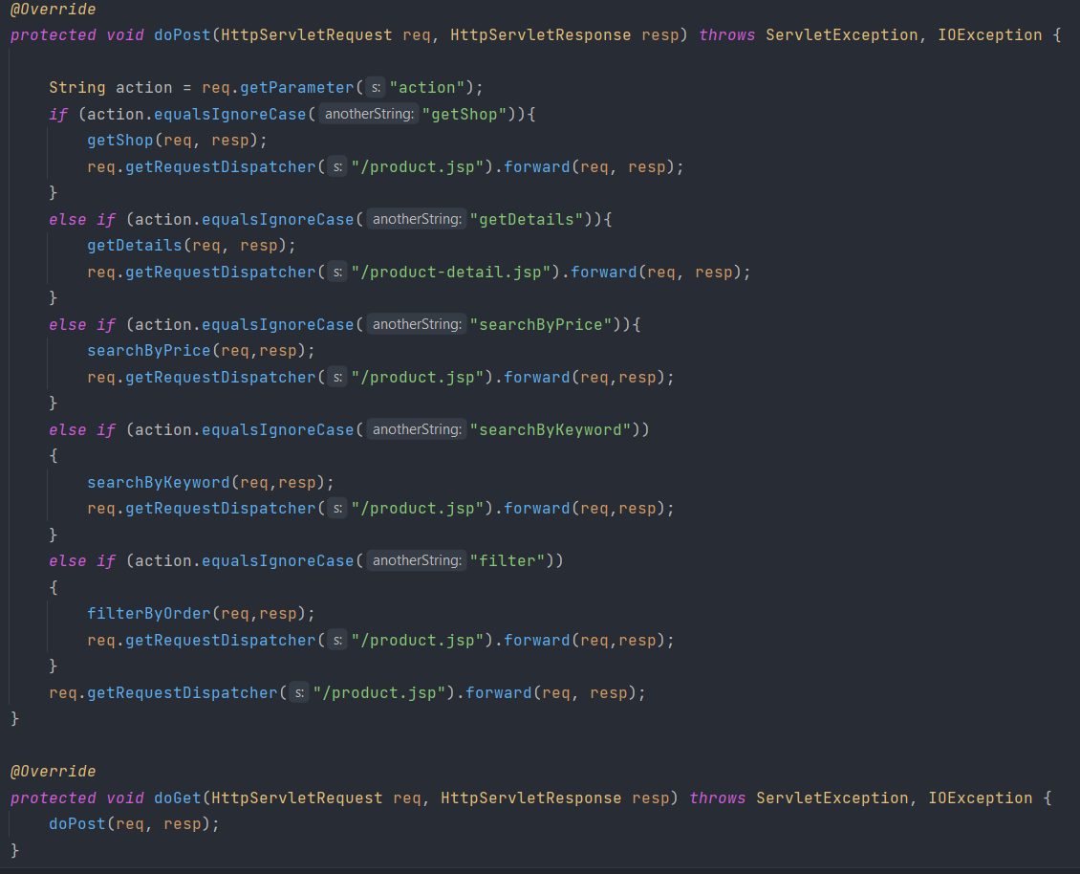

Figure 4.37. Customer product controller function

Table 4.8.. Customer product controller function description

|  |  |
| --- | --- |
| **Method name** | **Description** |
| getShop | Retrieves a list of all products and active categories.  Sets attributes in the request object (categoryList, productList, productIds) to be used by the JSP page. |
| getDetails | Retrieves details for a specific product (includes reviews by calling ReviewController and product basic details) based on the provided product ID and sets attributes to the request which will display on the JSP page.  Checks if the product is out of stock and sets an attribute (isOutOfStock) accordingly. |
| searchByPrice | Retrieves products within a specified price range provided in the request and return a product list that in a price range. |
| searchByKeywords | Retrieves products based on a keyword provided in the request and set these to the request object. |
| filterByOrder | Filters products based on selected product IDs and a sorting flag (ascending/ descending) and set the filtered product list to display on JSP page. |

#### Review Controller

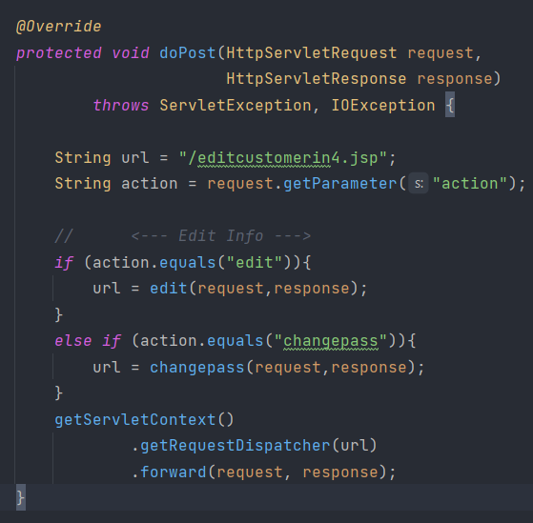

Figure 4.38. Review controller function

Table 4.9. Review controller function description

|  |  |
| --- | --- |
| **Method name** | **Description** |
| edit | Creates a new Review object for a product (if user has logged in bought the product) and inserts it into the database based on provided information (customer info and product info). |
| changepass | Retrieves reviews for a specific product and necessary information for the JSP page to implements. |

### Service

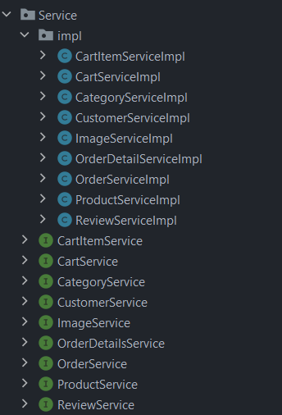

Figure 4.39. Customer service implementation

Besides, within each controller, specific services are required to address tasks associated with particular methods. In this project, we adopt an interface service - a structure that outlines methods, coupled with a Java class, "serviceimpl," to execute those methods within the service interface. This approach enhances our ability to effectively manage tasks that interact with model rather than interact directly from Controller.

# CONCLUSION

## Task manager

|  |  |  |  |  |
| --- | --- | --- | --- | --- |
| **No** | **Task** | **Function details** | **Progress** | **Member** |
| **Database** | | | | |
| 1 | Database | Create SQL databse and link database using JPA hibernate mapping | Done | Phuoc |
| **Front-end** | | | | |
| 2 | Front-end | Modifying and managing front-end using Coza bootstrap | Done | Quang |
| **Back-end** | | | | |
| Customer page | | | | |
| 3 | Login, register | * Login function, if doesn’t have account then head to register page to create account with a cart. * Forgot password with OTP send to email. | Done | Quang |
| 4 | Customer information | Create a customer and provide changing information. | Done | Quang |
| 5 | Product | * - Show list of selling products with information, proceed to product detail page to add to cart. * - Provide reviewing bought product. * - Filtering product by category and price. | Done | Phuoc |
| 6 | Cart | Showing cart, provide add, increase, decrease and delete product from cart. | Done | Phuoc |
| 7 | Order | Create orders, provide change shipping address or using default address in database and cancel order. | Done | Phuoc |
| Admin page | | | | |
| 8 | Customer manage | Changing customer information, ban customer. | Done | Quang |
| 9 | Product, order | * Product: Insert, disable and update products. * Viewing oders, change order status (cancel, confirm and complete. | Done | Phước |

## Project achivement

Building a website with full features of the user objects:

Building a website with all functionalities for different user types:

Customers:

* Sign up, log in and forgot password with OTP sending to emails.
* View and edit personal information.
* Search for products, filter based on categories and prices.
* Add to cart.
* Place orders.
* Review order history, cancel orders.
* Rate products upon order completion.

Admin:

* Manage customers.
* Manage products.
* Manage orders, confirm orders.

## Advantages and disadvantages

Advantages:

* Creating a logic database.
* Complete the basic function of the given project.
* Does include the dynamic function: reviews.
* User – friendly UI.

Disavantages:

* Product implementation logic is still not correctly (At color and size).
* Due to using low-end api which is servlet, the application is still quite slow.
* Lack of third-party login features like Google, etc.
* Limited online payment methods restricted.
* Integration of product recommendation system and customer communication through a chatbot is yet to be implemented.

## Future developments

* Add third-party login functionality.
* Incorporate multiple online payment methods like PayPal, Momo, etc.
* Enhance the search feature with more extensive filters.
* Introduce a product comparison feature for similar items.
* Allow users to access more detailed information about their assigned delivery person (name, gender, photo, contact number, type and color of their vehicle) and include a section for reviewing the delivery personnel.
* Improve performance, address bugs, and implement new technologies into the project.

# REFERENCES

[1] Murach’s Java Programming (6th Edition). From: <https://www.murach.com/shop/murach-s-java-programming-6th-edition-detail>

[2] Inteliji tutorial. From <https://www.youtube.com/@intellijidea>

[3] Coza Store Bootrap copyright. From: <https://themewagon.com/themes/free-html5-ecommerce-website-template/>

[4] Hades’s page survey. From: <https://hades.vn/>

[5] SoVintage’s page survey. From: <https://sovintage.com.vn/>